Patient information
Community Treatment of Cellulitis

The medication treatment:
You have been diagnosed with an infection of the skin called cellulitis.

Your doctor has put you on to antibiotics to help fight the infection.

It is very important that you take all your antibiotics to ensure that the infection improves. Please complete the course of antibiotics even if you are feeling better before the end of the course.

Elevate your infected arm or leg above your heart: 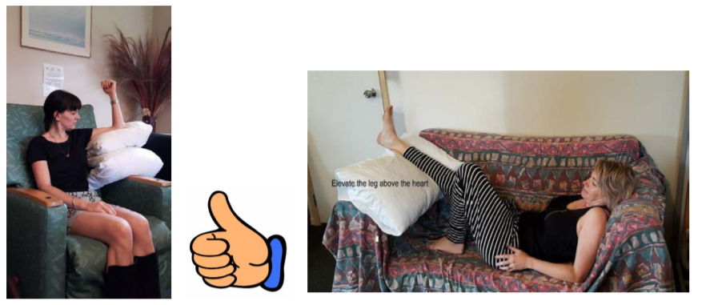
Why?
Elevation is as important as your antibiotics in treating your cellulitis.
- It reduces swelling
- It reduces pain
- It improves the circulation of antibiotic
- It may prevent a stay in hospital
When?
- Elevate the affected limb the MAJORITY of the day
- You may get up for a short time every hour, e.g. to go to the toilet or get some food/drink
- You should remain off work and avoid heavy housework/DIY/gardening
How long?
- Elevate for a few days, depending on how severe, until improvement (or your doctor advises)
- If you do not elevate, the success of your treatment may fail and you may end up in hospital

General:
Rest and allow yourself to recover. Drink plenty of water.

Wound care:
If you have an open wound, keep it clean and covered with a dressing.

Follow Up:
Follow-up appointments for your cellulitis are free of charge. Your GP should have discussed with you when they would like to see you again. If you think you need to be reviewed sooner than your booked appointment you can attend an afterhours GP at no cost

Your doctor will want to see you sooner if:
- You have symptoms of an allergic reaction.
  - If you experience severe symptoms such as swelling around the mouth, difficulty breathing, or you collapse – please call an ambulance.
  - For milder symptoms such as a rash or diarrhoea – please see your doctor before taking further antibiotics.
- You start to feel more unwell and ‘flu-like’ with a worsening fever, uncontrollable shakes, light-headedness or dizziness. Drinking water/fluids and taking paracetamol may help with these symptoms. Seek medical advice if you do not improve.
- You think the pain and swelling in your arm / leg is getting worse. Your healthcare provider may draw a line around the redness. It is not unusual for the redness to spread and get a little worse before it gets better, but if increasing redness is associated with pain and swelling, please seek further advice.
- Your skin starts to weep and open up like a wound.

