 

# POSITION DESCRIPTION

|  |  |  |
| --- | --- | --- |
| **Position**: | **Information Systems Application Support Specialist** | |
| **Responsible to:** | **Applications & ISSP Programme Manager** | |
| **Location:** | Rotorua & Taupo | |
| **Functional relationships:** | **Internal**:  Clerical Staff  Nursing Staff  Allied Health Staff  Medical Staff  Other Departments | **External**:  Other DHBs in the Midland Region  HealthShare  IS Vendors |
| **Financial delegations:** | None | |
| **Date**: | Oct 2020 | |

### Primary purpose(s) of the position

The Application Support Specialist’s role is to deliver support to end users in the organisation about how to use various types of software programs efficiently and effectively in fulfilling business objectives. This includes troubleshooting applications and software for all internal customers, such as operations, development, and other business units. The Application Support Analyst is also responsible for assisting in the design, delivery, and improvement of in-house software applications training programs and related courseware.

|  |  |  |
| --- | --- | --- |
| **Key Objectives** | **Description** | **Expected Outcomes** |
| **Strategic Planning** | * Maintain in-depth knowledge of company’s strategic business plans as the DAP, DSP, ISSP and regional and national plans such as the RISSP and HIS-NZ. * Participate in IT department operational and strategic planning including fostering innovation, planning projects, and organize and negotiate the allocation of resources. * Gauge the effectiveness and efficiency of existing systems; develop and implement proposals for improving or further leveraging these systems. | * Able to articulate and explain information systems decisions and strategies in relation to the strategic documents. * Documented proposals and initiatives are in line with organisational goals and strategies. |
| **Customer Service** | * Communicate application problems and issues to key stakeholders, including management, development teams, end users, and unit leaders. * Test fixes and perform post-resolution follow-ups to ensure problems have been adequately resolved. * Coordinate with department heads to assess departmental application training needs and objectives. * Post software updates, drivers, knowledge bases, and frequently asked questions resources on company intranet to assist in problem resolution. * Maintain Lakes DHB Information Systems service level agreements in relation to application support. * Maintain an awareness of Service needs, particularly with reference to Information Systems. | * Post software updates, drivers, knowledge bases, and frequently asked questions resources on company intranet to assist in problem resolution. * Maintain Lakes DHB Information Systems service level agreements in relation to application support. * Maintain an awareness of Service needs, particularly with reference to Information Systems. |
| **Application Support** | * Business as usual (BAU) application support for the Lakes Clinical Applications, including Clinical Information System, Galen Patient Management System, Electronic Document Management System, Content Management System, Microsoft Office Applications, Telecommunication Systems, Rhapsody, Éclair and Orion CWS. Provide systems analysis for change requests. * Provide level 2 application support to the Support Desk (rotational). * Provide assistance with Disaster Response Planning (DRP) and Business Continuity Planning for core business applications. * Create and deploy feedback mechanisms for end users. Analyse results, make recommendations for support process improvement, and implement changes. * Field incoming (level 2) problem tickets from end users to resolve application and software issues within servers, databases, and other mission-critical systems. * Prioritize, schedule, and administer all instances where enhancements and defect resolution are required. * Maintain and enhance performance of all new and existing software and applications across the organization. * Identify and learn appropriate software applications used and supported by the organization. * Participate in the design, development, and delivery of software applications training programs and individual classes. * Provide support for the testing of new and existing software applications under development or consideration for purchase. * Apply diagnostic utilities to aid in troubleshooting. * Conduct research into software application products and services in support of development and purchasing efforts. | * Effective application support for the core systems used by Lakes DHB. * Application change requests are analysed to assess impact on end users. * DR and BC plans include the loss of core applications and recovery processes from the outage. * Application defects are recorded, reported and resolved in accordance with service levels. * Become expert in all core business applications. * Participate as required, and ensure effectiveness of end user training programmes. * End user feedback is analysed and used to recommend application enhancements. * Participate in the testing of new applications ensuring the systems are fit to release into the live environment. * Documented recommendations to enhance or implement new systems are provided to senior management. |
| **Application Testing** | * Evaluate, plan, design, develop, and deploy testing techniques for new applications, products, and/or enhancements to existing applications throughout their development/product lifecycles. * Ensure that testing activities will allow applications to meet business requirements and systems goals, fulfil end-user requirements, and identify and resolve systems issues. * Create and execute test scripts, cases, and scenarios that will determine optimal system performance according to specifications. * Conduct all types of application testing as needed, such as system, unit, regression, load, and acceptance testing methods. * Analyse formal test results in order to discover and resolve defects, bugs, errors, configuration issues, and interoperability flaws. * Collaborate with analysts, designers, and system owners in the testing of new software programs and applications. * Analyse documentation and technical specifications of any new application under deployment or consideration to determine its intended functionality. * Ensure that any new software integration into company systems meets functional requirements, system compliance, and interface specifications. * Review and analyse the effectiveness and efficiency of existing systems and develop testing strategies for improving or leveraging these systems. * Produce reports and documentation for all testing efforts, results, activities, data, logging, and tracking. * Communicate test progress, test results, and other relevant information to project stakeholders and management. * Contribute to pre-testing phase of project development by evaluating proposals in order to identify potential problem areas, and make the appropriate recommendations. * Develop, distribute, and coordinate in-depth end-user reviews for modified and new systems or applications. * Take an active role in cross-departmental projects when needed. * Cultivate and disseminate knowledge of application-testing best practices. | * New applications introduced into Lakes DHB work as expected and are substantially bug free. * Projects managers, vendors and developers are aware of any bugs, defects and configuration issues. * New applications / software support Lakes DHB’s business requirements. * High quality documentation exists for all testing efforts and the results of the testing. |
| **Administration** | * Use Help Desk system to document all pertinent end user identification information, including name, department, contact information, and nature of problem or issue. * Use Help Desk system to record, track, and document the problem-solving process, including all successful and unsuccessful decisions made, and actions taken, through to final resolution. * Evaluate documented resolutions and analyse trends for ways to prevent repeated future problems. * Assist with the development of business case justifications and cost/benefit analyses for IT spending and initiatives. * Conduct research and remain current with the latest technologies and solutions in support of procurement efforts. * Knowledge bases maintained in Support Desk system. | * All end user support requests and resolutions are thoroughly documented and recorded in the Support Desk system. * Recommendations on how to prevent repeated problems are documented and provided to senior management |
| **Vendor Support** | * Vendor SLA and contract monitoring * Investigate vendor’s technology opportunities for Information Systems solutions to support the organisations requirements. * Work closely with vendor’s support desk to resolve end user problems. | * Thorough understanding of vendor’s service levels and contracts which are monitored for compliance. * Knowledge of vendors’ products and services and their application to Lakes DHB’s organisational requirements. * Vendors advised on effectiveness of their products and services. * Vendors adhere to Lakes DHB standards, policies and procedures. |
| **Security** | * Work with Operational Team to ensure new systems maintain the integrity and security of Lakes DHB information. * Assist Operational Team with security audits and monitor application audit trails. * Maintain knowledge of applicable data privacy practices and laws. | * End users are fully aware of the need for security of information systems and their use. * Discrepancies found in audit trails are promptly actioned. * Application enhancements or new systems are “security” approved by the Operations Team for implementation into the live environment. |



|  |  |  |
| --- | --- | --- |
| **Capabilities** | Capability definition | Achievement Indicators  *(Examples – add/ amend or delete as specific to role using matrix to assist)* |
| **Communication and Personal Interaction**  **Te Ringa Hora**  ***the open hand (denoting someone who is sociable)*** | Openly communicates and cooperates with all levels of DHB employees, patients and visitors. | * Listens actively, absorbs message and responds appropriately. * Builds effective working relationships. * Establishes rapport with others and gains their respect while being adaptive in relating to different types of people and situation. * Openly and constructively participates in conversations with md team, patients, managers and visitors * Patients and visitors are appropriately welcomed and treated while within the DHB * Collegiality with team mates and teams * Accepts differences of opinion can occur but these happen respectfully and without any continued animosity |
| **Strategy & Performance**  **Te Ringa Raupā**  ***the roughened hand (symbolising a hard worker)*** | Spends energy on delivering role requirements and meeting objectives | * Has an energetic approach to work and is self-motivated. * Accepts direction and instruction of manager but is able to work effectively without direction or guidance. * Organises time and resources effectively. * Understands and work towards achievement of the organisation’s goals. * On shift is busy completing shift duties. |
| Organises own time to deliver on required tasks and duties | * Utilises effective time management strategies to meet shift duties and works towards achieving objectives in any spare moments. |
| **Development and Change**  **Te Ringa Ahuahu**  ***the hand that shapes or fashions something (refers to someone who is innovative)*** | Accepts change in day to day practices and contributes to decision making of the team. | * Can adjust behaviour to the demands of the work environment in order to remain productive through periods of transition, ambiguity, uncertainty and stress |
| Makes suggestions to increase efficiency of the unit. | * Works with managers and team to make any changes within practices work * Contributes to change processes, offering solution based ideas * Constructively makes suggestions to improve process or practices and gain efficiencies * Accepts when ideas are not accepted for implementation |
| **Personal Accountability**  **Te Ringa Tōmau**  ***the hand that is trustworthy*** | Is open with manager and colleagues and open to accepting feedback and critique to improve upon practice. | * Offers constructive criticism and accepts feedback. * Establishes rapport with others and gains their respect while being adaptive in relating to different types of people and situations, to allow improvements to be made. * Accepts all feedback and participates in feedback discussions appropriately * Responds and queries how improvements can be made * Advises manager wherever issues may be impacting on performance |
| Looks for and undertakes development activities appropriate for role and career development. | * Recognises areas that could be improved in own practice * Requests learning and development opportunities to enhance practice in role and/ or to assist where improvements can be made * Recognises and facilitates the rights of Māori clients and their whanau to participate in cultural activities. * Has a working knowledge of the Lakes DHB Māori communities. |
| **Culture and Values**  **Te Ringa Taurima**  ***the hand that nurtures, encourages, supports*** | Operates in line with DHB values and expectations and professional codes of conduct. | * Demonstrates a commitment to cultural safety by meeting and exceeding the cultural needs of clients/ customers/ colleagues. * Incorporates the Lakes Way into day to day business activities * Shows respect for patients, colleagues,managers, md teams * Utilises the Lakes Way philosophy to engage with patients, visitors and multi-disciplinary teams |
| **Māori Health** | Māori philosophies and values of health are demonstrated in work practice. | * Meaningful relationships are established with Te Huinga Takiora Māori in the planning and delivery of services. * Practices are consistent with Te Tiriti o Waitangi /The Treaty of Waitangi when working with Māori. * Delivery of safe services for Māori are facilitated by ensuring they can access treatment options and are involved in the planning and delivery of their care. * Māori are enabled to access and participate in cultural activities provided by the Lakes DHB. * A commitment to improving the wellbeing of Māori by increasing cultural knowledge in the Lakes DHB is shown. |
| **Te Iti Kahurangi** | The Lakes Way, Our Place Our Culture | * Works within the Te Iti Kahurangi framework and supporting guide document. |
| **Record Keeping** |  | * Complies with the Lakes DHB Corporate Records Management policy to create and maintain full and accurate records. |
| **Quality & Risk** | Patient safety is paramount to the service we deliver at Lakes District Health Board. This is to be achieved in a clinical governance framework that is culturally responsive and identifies and manages risk and opportunities to improve. | * Employees are supported to lead by example and implement a culture of continuous quality improvement. * Risks that may prevent Lakes DHB from achieving their goals are identified, reported, and managed. * Māori patients are provided patient-centred care to achieve positive Māori health outcomes. * Needs of Māori are reviewed and reported in the further development of practice, process and or policy. * Evidence-based methodologies are used to support improvements, e.g. kaupapa Māori methodology. * Quality care is provided to certification standards. |
| **Health & Safety** | Each individual is responsible for ensuring the safety of themselves, their colleagues, patients and their visitors and to comply with all organisational health and safety policies, procedures and guidelines. | * Implementation and reinforcement of a proactive healthy work place culture which reflects relevant Lakes DHB policy and legislative requirements. * Healthy lifestyles are actively promoted and participated in, within the work area. * Employees participate in Health and Safety within areas of work. * Health and Safety activities are appropriately documented within specified timeframes. * Health and Safety policies have been read and understood and are applied in the workplace. * Health and Safety policies are appropriately documented within specified timeframes and incidents are reported immediately. * Any opportunities for improving Health and Safety are reported and acted upon in a timely manner. * All near misses/incident/accidents are reported to the appropriate line manager within 24 hours. |

**Signatures:**

|  |  |
| --- | --- |
| Line Manager:  (position description approved): |  |
| Employee:  (acceptance of position description): |  |

*(Please also initial all other pages to show acceptance of position description.)*

|  |  |  |
| --- | --- | --- |
| **Person Specification** | **Essential:** | **Desirable:** |
| **Education and Qualifications:** | * UML (Use Case and Business Process) or similar systems analysis methodology | * Project Management Professional (PMI). * College diploma or university degree in the field of computer science, information systems. |
| **Experience:** | * Proven experience with troubleshooting principles, methodologies, and issue resolution techniques. * Able to develop and interpret technical documentation for training and end user procedures. * Ability to conduct research into software development and delivery concepts, as well as technical application issues. * Experience at working both independently and in a team-oriented, collaborative environment | * Previous experience supporting Health applications * How to Implement ITIL: Integrating People & Tools with Processes * In-depth, hands-on knowledge of and experience with enterprise and desktop applications, including patient management systems, clinical information systems, web based information systems (content management system, electronic document management systems). * Experience with SQL * Experience working in a team-oriented, collaborative environment. |
| **Knowledge:** | * Familiar with the use of Microsoft applications. | * Knowledge of trends in technology relating to software applications. * Good understanding of the organization’s goals and objectives. * Familiar with project management techniques and software, such as Microsoft Project. * Familiar with the health industry. * Familiar with the technical requirements of telephony systems, computer systems, applications and networks. |
| **Skills:** | * Excellent software troubleshooting ability * Excellent written, oral, interpersonal, and presentational skills. * Ability to deliver training sessions as required * Ability to absorb new ideas and concepts quickly. |  |
| **Personal Attributes:** | * Can conform to shifting priorities, demands, and timelines. * Highly self motivated and directed. * Good analytical and problem-solving abilities. * Ability to effectively prioritize and execute tasks in a high-pressure environment. * Ability to present ideas in business-friendly and user-friendly language Very strong customer service orientation. * Ability to relate to all levels of customers. | * Non-smoker preferred. * Must be able to learn, understand, and apply new technologies. * Able to manage a high volume of work without compromising on quality and outputs. |

**ABOUT LAKES DISTRICT HEALTH BOARD**

At Lakes District Health Board we place the highest value on the health and wellbeing of everyone in our community. As such all healthcare workers are expected to play a part in the creation and promotion of an environment which lives the following vision, mission and values:

**VISION**

Healthy Communities – Mauriora! In this vision Mauriora refers to the Mauri - being the life essence and the source of well being, and ora - describing the state of wellness.

**STRATEGIC MISSION**

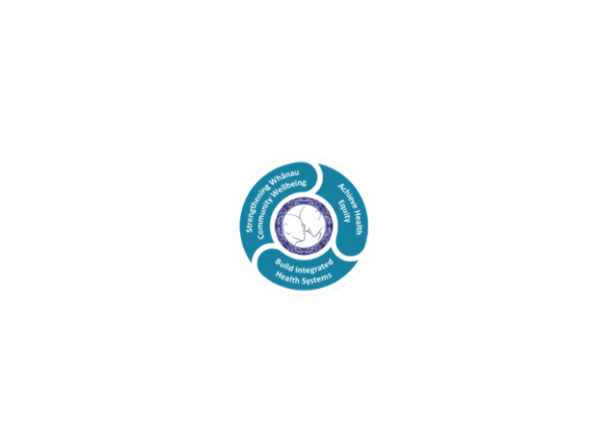

* Achieve equity in Māori health
* Build an Integrated health system
* Strengthen people, whanau & community wellbeing

**THREE CORE VALUES**

Manaakitanga respect and acknowledgment of each other’s intrinsic value and contribution

Integrity truthfully and consistently acting collectively for the common good

Accountability collective and individual ownership for clinical and financial outcomes and sustainability

**TE ITI KAHURANGI – THE LAKES WAY, OUR PLACE, OUR CULTURE – WE WILL**

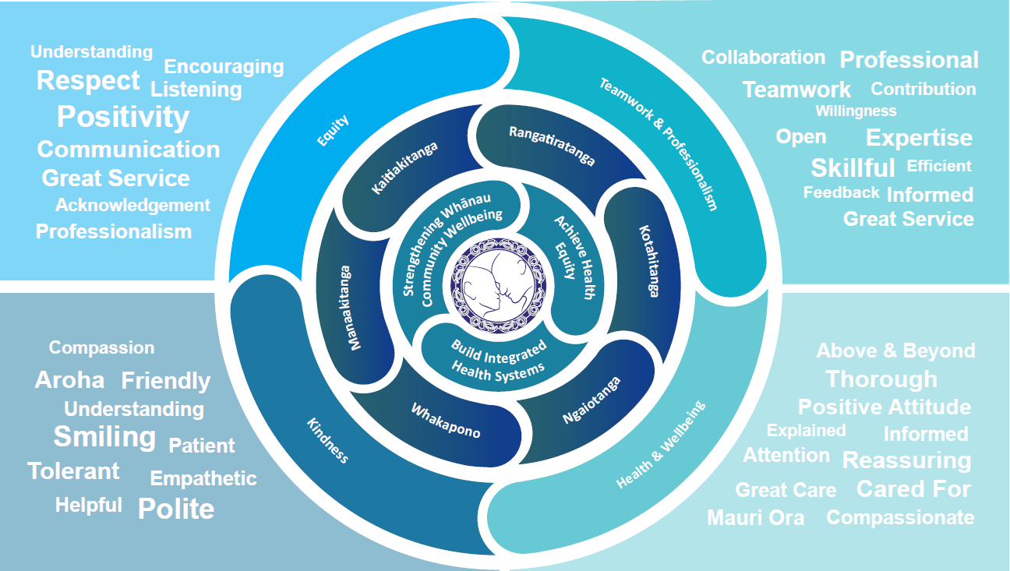

**TE TIRITI O WAITANGI**

**Our expression of Te Tiriti o Waitangi**

The text of Te Tiriti, including the preamble and the three articles, along with the Ritenga Māori declaration, are the enduring foundation of our approach to achieving health and independence. Based on these foundations, we will strive to achieve the following four goals, each expressed in terms of mana.

**Mana whakahaere**

Effective and appropriate kaitiakitanga and stewardship over the health and disability system. Mana whakahaere is the exercise of control in accordance with tikanga, kaupapa and kawa Māori. This goes beyond the management of assets and resources and towards enabling Māori aspirations for health and independence.

**Mana motuhake**

Enabling the right for Māori to be Māori (Māori self-determination); to exercise their authority over their lives and to live on Māori terms and according to Māori philosophies, values and practices, including tikanga Māori.

**Mana tangata**

Achieving equity in health and disability outcomes for Māori, enhancing the mana of people across their life course and contributing to the overall health and wellbeing of Māori.

**Mana Māori**

Enabling Ritenga Māori (Māori customary rituals), which are framed by te ao Māori (the Māori world), enacted through tikanga Māori (Māori philosophy and customary practices) and encapsulated within mātauranga Māori (Māori knowledge).

Lakes DHB is committed within the framework of the New Zealand Public Health and Disability Act (2000) to supporting the Crown’s commitment to upholding its Tiriti promises.

**ORGANISATION STRUCTURE**

