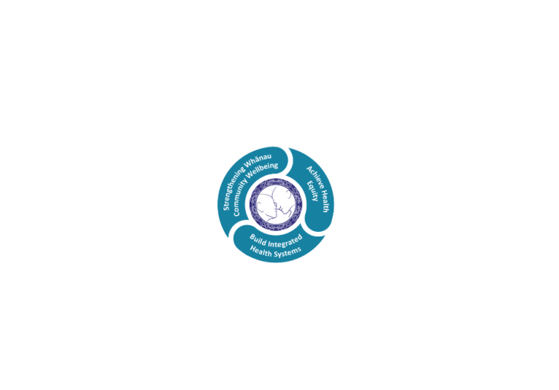



# POSITION DESCRIPTION

|  |  |  |
| --- | --- | --- |
| **Position**: | Medical Transcriptionist – Medicine Services.. | |
| **Responsible to:** | Admin Team Leader, Medicine Services | |
| **Direct Reports:** | Admin Team Leader, Medicine Services | |
| **Location:** | Rotorua | |
| **Functional relationships:** | **Internal:**  Service Manager  Administration Support  Physician Secretaries  Consultant Physicians  Medical Registrars  House Officers  Visiting Clinicians  Clinical Nurse Specialists  Outpatient co-ordinator  Clinical Records  Transcriptionists from other services  Other services as required | **External**:  General Practitioners  Consultants Private Practice  Other DHBs. |
| **Date**: | February 2021 | |

### Primary purpose(s) of the position

To provide an effective, timely clinical transcription service to Medicine Services

|  |  |  |
| --- | --- | --- |
| **Key Objectives** | Description | Expected Outcomes |
| **Word Processing** | To provide, as required, a consistently high standard of medical word processing and database typing for medical and other staff as required. | * Manages transcription through the dictation system in priority. * Timely and accurate processing of workload. * Achievement of high standards of presentation and quality. * Word processing to be appropriately formatted, and edited where necessary. * Must adhere to written policies and procedures which reflect current organisational standards and guid medical transcriptionists in their duties. * Manages to meet minimum expected performance standards of 60 minutes transcription per day, which allows time for filing, correcting and mailing. * Provide medical transcription for the following personnel: * Consultant Physicians * Medical Registrars * House Officers * Visiting Consultants/doctors * Nurse Specialists * Other services as requested * To establish and maintain harmonious interpersonal relationships with hospital personnel and all medical staff. * Reports, correspondence, photocopying are returned/distributed as necessary in the approved manner and within the allotted time. * A high degree of confidentiality is maintained. * When sending transcription to visiting doctors for verification via email, ensure that secure networks are utilised. * That procedures which are established to evaluate the quality of service is provided. * Documents sent to authors for editing are monitored and any consistent delays are communicated to Admin Team Leader. * Documents returned from authors to be double checked for correctness prior to being printed, uploaded and distributed. * Dictation is recorded in log books and updated upon receipt of returned documents and uploading. * Referral letters are sent to Referral Centre |
| **Team Work** | To ensure that a welcoming and courteous reception is provided for internal and external customers who seek assistance from the Medical Transcription Service. | * Members of staff receive friendly and helpful attention at all times. * Deal with enquiries or requests in a courteous and helpful manner, ensuring customer satisfaction at all times. * Enhance team effort and work effectively as a member of the team. |
| **Clinical Verification** | To ensure patient clinical notes are electronically updated in the CIS system as soon as verified by Clinician | * All patient-related information transcribed is accurately electronically uploaded into the CIS system as soon as verified by the clinician. * Only “verified” clinical letters to be electronically uploaded to LCWS and filed in patient clinical notes. |
| **Service** | Ensure an efficient service is maintained to meet departmental requirements at all times | * To liaise with Administration Team Leader on applications for annual leave, staff replacements, and other such matters where necessary. * Ensure supply of letterhead, photocopy paper and envelopes are available. Liaise with Secretaries/Admin Support if needing to reorder. |
|  |  |  |

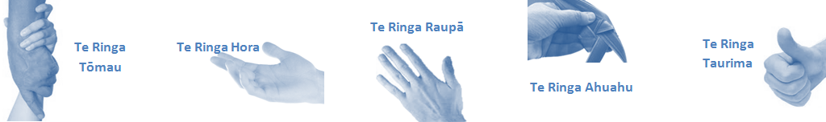

|  |  |  |
| --- | --- | --- |
| **Capabilities** | Capability definition | Achievement Indicators |
| **Communication and Personal Interaction**  **Te Ringa Hora**  ***the open hand (denoting someone who is sociable)*** | Openly communicates and cooperates with all levels of DHB employees, patients and visitors. | * Listens actively, absorbs message and responds appropriately. * Builds effective working relationships. * Establishes rapport with others and gains their respect while being adaptive in relating to different types of people and situation. * Openly and constructively participates in conversations with md team, patients, managers and visitors * Patients and visitors are appropriately welcomed and treated while within the DHB * Collegiality with team mates and md teams * Accepts differences of opinion can occur but these happen respectfully and without any continued animosity |
| **Strategy & Performance**  **Te Ringa Raupā**  ***the roughened hand (symbolising a hard worker)*** | Spends energy on delivering role requirements and meeting objectives | * Has an energetic approach to work and is self motivated. * Accepts direction and instruction of manager but is able to work effectively without direction or guidance. * Organises time and resources effectively. * Understands and work towards achievement of the organisation’s goals. * On shift is busy completing shift duties. |
| Organises own time to deliver on required tasks and duties | * Utilises effective time management strategies to meet shift duties and works towards achieving objectives in any spare moments. |
| **Development and Change**  **Te Ringa Ahuahu**  ***the hand that shapes or fashions something (refers to someone who is innovative)*** | Accepts change in day to day practices and contributes to decision making of the team. | * Can adjust behaviour to the demands of the work environment in order to remain productive through periods of transition, ambiguity, uncertainty and stress |
| Makes suggestions to increase efficiency of the unit. | * Works with managers and team to make any changes within practices work * Contributes to change processes, offering solution based ideas * Constructively makes suggestions to improve process or practices and gain efficiencies * Accepts when ideas are not accepted for implementation |
| **Personal Accountability**  **Te Ringa Tōmau**  ***the hand that is trustworthy*** | Is open with manager and colleagues and open to accepting feedback and critique to improve upon practice. | * Offers constructive criticism and accepts feedback. * Establishes rapport with others and gains their respect while being adaptive in relating to different types of people and situations, to allow improvements to be made. * Accepts all feedback and participates in feedback discussions appropriately * Responds and queries how improvements can be made * Advises manager wherever issues may be impacting on performance |
| Looks for and undertakes development activities appropriate for role and career development. | * Recognises areas that could be improved in own practice * Requests learning and development opportunities to enhance practice in role and/ or to assist where improvements can be made * Recognises and facilitates the rights of Māori clients and their whanau to participate in cultural activities. * Has a working knowledge of the Lakes DHB Māori communities. |
| **Culture and Values**  **Te Ringa Taurima**  ***the hand that nurtures, encourages, supports*** | Operates in line with DHB values and expectations and professional codes of conduct. | * Demonstrates a commitment to cultural safety by meeting and exceeding the cultural needs of clients/ customers/ colleagues. * Incorporates the Lakes Way into day to day business activities * Shows respect for patients, colleagues, * managers, md teams * Utilises the Lakes Way philosophy to engage with patients, visitors and md teams |

|  |  |  |
| --- | --- | --- |
| **Compulsory Requirements** | Description | Expected Outcomes |
| **Māori Health** | Māori philosophies and values of health are demonstrated in work practice. | * Meaningful relationships are established with Te Huinga Takiora Māori in the planning and delivery of services. * Practices are consistent with Te Tiriti o Waitangi /The Treaty of Waitangi when working with Māori. * Delivery of safe services for Māori are facilitated by ensuring they can access treatment options and are involved in the planning and delivery of their care. * Māori are enabled to access and participate in cultural activities provided by the Lakes DHB. * A commitment to improving the wellbeing of Māori by increasing cultural knowledge in the Lakes DHB is shown. |
| **Te Iti Kahurangi** | The Lakes Way, Our Place Our Culture | * Works within the Te Iti Kahurangi framework and supporting guide document. |
| **Record Keeping** |  | * Complies with the Lakes DHB Corporate Records Management policy to create and maintain full and accurate records. |
| **Quality & Risk** | Patient safety is paramount to the service we deliver at Lakes District Health Board. This is to be achieved in a clinical governance framework that is culturally responsive and identifies and manages risk and opportunities to improve. | * Employees are supported to lead by example and implement a culture of continuous quality improvement. * Risks that may prevent Lakes DHB from achieving their goals are identified, reported, and managed. * Māori patients are provided patient-centred care to achieve positive Māori health outcomes. * Needs of Māori are reviewed and reported in the further development of practice, process and or policy. * Evidence-based methodologies are used to support improvements, e.g. kaupapa Māori methodology. * Quality care is provided to certification standards. |
| **Health & Safety** | Each individual is responsible for ensuring the safety of themselves, their colleagues, patients and their visitors and to comply with all organisational health and safety policies, procedures and guidelines. | * Implementation and reinforcement of a proactive healthy work place culture which reflects relevant Lakes DHB policy and legislative requirements. * Healthy lifestyles are actively promoted and participated in, within the work area. * Employees participate in Health and Safety within areas of work. * Health and Safety activities are appropriately documented within specified timeframes. * Health and Safety policies have been read and understood and are applied in the workplace. * Health and Safety policies are appropriately documented within specified timeframes and incidents are reported immediately. * Any opportunities for improving Health and Safety are reported and acted upon in a timely manner. * All near misses/incident/accidents are reported to the appropriate line manager within 24 hours. |

**Signatures:**

|  |  |
| --- | --- |
| Line Manager:  (position description approved): |  |
| Employee:  (acceptance of position description): |  |

*(Please also initial all other pages to show acceptance of position description.)*

|  |  |  |
| --- | --- | --- |
| **Person Specification** | **Essential:** | **Desirable:** |
| **Education and Qualifications:** | * Advanced Microsoft Product Skills, i.e. Excel, Word, Outlook | * Medical terminology certificate |
| **Experience:** | * Previous clinical transcription experience. * Good understanding of the language of medicine. * Sound knowledge of medical/clinical terminology preferred (e.g. human anatomy, physiology and disease process) can be substituted by years of experience. |  |
| **Knowledge:** | * Te Tiriti O Waitangi in the provision of health care services and support to Māori. * Te Tiriti O Waitangi in practice, process, policy development and decision making. * Indepth knowledge of the Privacy Act * Knowledge of Lakes DHB Catchment area |  |
| **Skills:** | * Pronunciation of Te Reo Māori words and names * Excellent grammatically with good spelling knowledge. * Capable of achieving a high accuracy rate of transcription. * Basic knowledge of filing system. * Telephone skills. * Computer literate/good transcription skills.. | * Te Reo Māori |
| **Personal Attributes:** | * Effective communication and interpersonal skills. * Capable of working autonomously and as a team player. * Self motivated and uses initiative. * Proven ability to be flexible and set priorities. * Ability to maintain a calm disposition under stress. * Can effectively cope with change. * Respect patient confidentiality.   Maintain and extend knowledge of skill base – relevant issues, trends and practices for effective performance. | * Non-smoker preferred. |

**ABOUT LAKES DISTRICT HEALTH BOARD**

At Lakes District Health Board we place the highest value on the health and wellbeing of everyone in our community. As such all healthcare workers are expected to play a part in the creation and promotion of an environment which lives the following vision, mission and values:

### VISION

Healthy Communities – Mauriora! In this vision Mauriora refers to the Mauri - being the life essence and the source of well being, and ora - describing the state of wellness.

### STRATEGIC MISSION

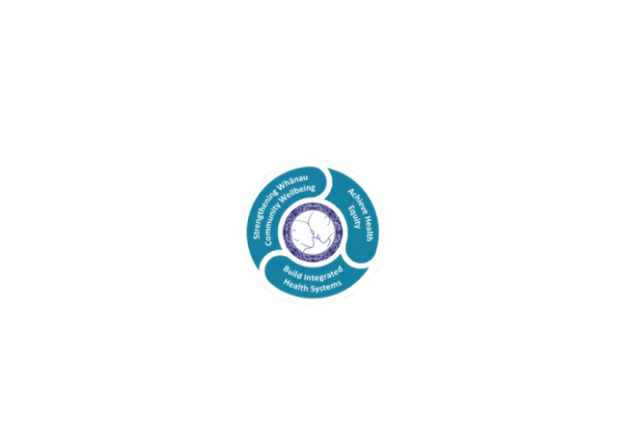

* Achieve equity in Māori health
* Build an Integrated health system
* Strengthen people, whanau & community wellbeing

### THREE CORE VALUES

Manaakitanga respect and acknowledgment of each other’s intrinsic value and contribution

Integrity truthfully and consistently acting collectively for the common good

Accountability collective and individual ownership for clinical and financial outcomes and sustainability

### TE ITI KAHURANGI – THE LAKES WAY, OUR PLACE, OUR CULTURE – WE WILL

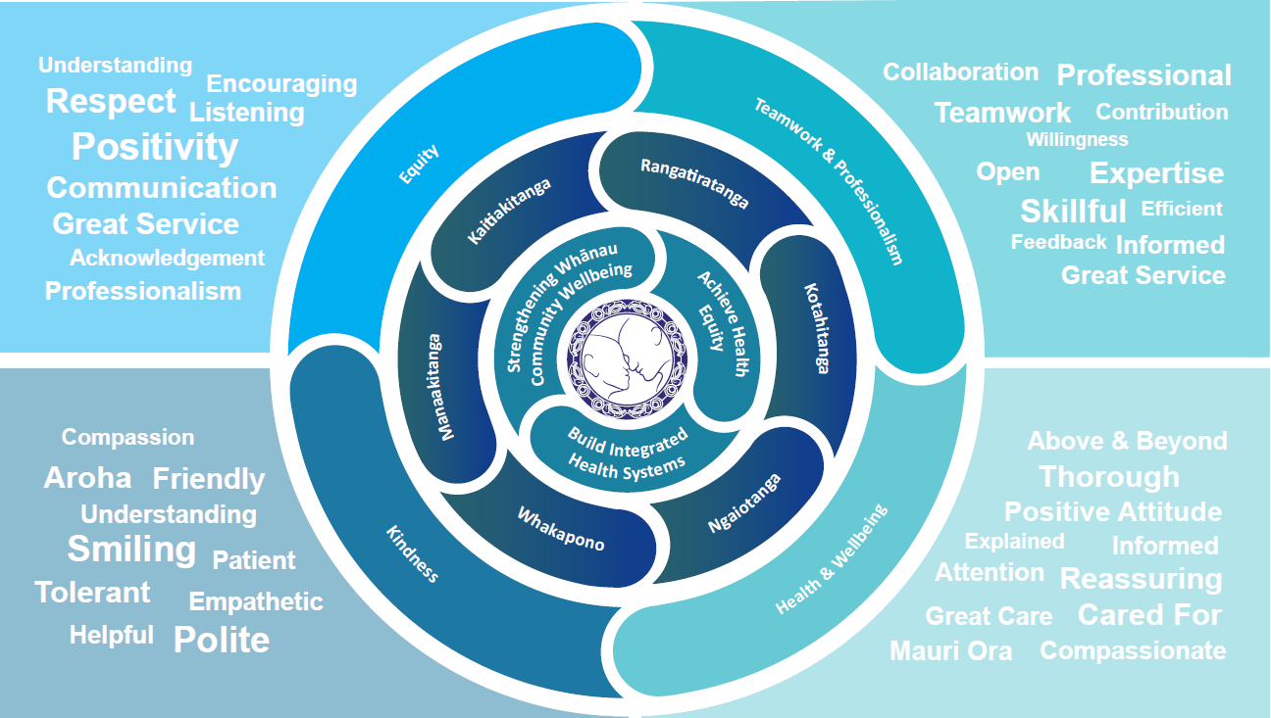

### TE TIRITI O WAITANGI

**Our expression of Te Tiriti o Waitangi**

The text of Te Tiriti, including the preamble and the three articles, along with the Ritenga Māori declaration, are the enduring foundation of our approach to achieving health and independence. Based on these foundations, we will strive to achieve the following four goals, each expressed in terms of mana.

**Mana whakahaere**

Effective and appropriate kaitiakitanga and stewardship over the health and disability system. Mana whakahaere is the exercise of control in accordance with tikanga, kaupapa and kawa Māori. This goes beyond the management of assets and resources and towards enabling Māori aspirations for health and independence.

**Mana motuhake**

Enabling the right for Māori to be Māori (Māori self-determination); to exercise their authority over their lives and to live on Māori terms and according to Māori philosophies, values and practices, including tikanga Māori.

**Mana tangata**

Achieving equity in health and disability outcomes for Māori, enhancing the mana of people across their life course and contributing to the overall health and wellbeing of Māori.

**Mana Māori**

Enabling Ritenga Māori (Māori customary rituals), which are framed by te ao Māori (the Māori world), enacted through tikanga Māori (Māori philosophy and customary practices) and encapsulated within mātauranga Māori (Māori knowledge).

Lakes DHB is committed within the framework of the New Zealand Public Health and Disability Act (2000) to supporting the Crown’s commitment to upholding its Tiriti promises.

### ORGANISATION STRUCTURE

