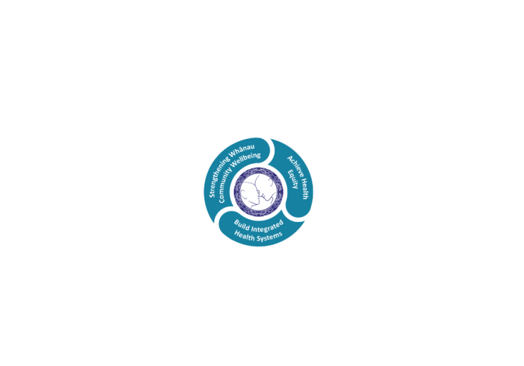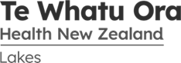

# POSITION DESCRIPTION

|  |  |  |
| --- | --- | --- |
| **Position:** | Team Leader/Professional Lead – Social Work | |
| **Responsible To:** | Operationally reporting to Service Manager Clinical Support Services  Professionally reporting to Director of Allied Health Scientific, Technical | |
| **Direct Reports:** | Approx. 11 FTE | |
| **Location:** | Rotorua & Taupō | |
| **Functional Relationships:** | **Internal:**  Patients/Clients  CSS Management Team  AH Team Leaders/ Managers  Clinical Nurse Managers  Nursing Staff  Medical Staff  Administration Staff  Allied Health Professionals | **External:**  Community Agencies  Primary Providers  Social Work Registration Board  Tertiary Education Providers |
| **Financial Delegations:** | As per the Te Whatu Ora Lakes DHB Delegation’s Policy (EDMS #40549)l | |
| **Date:** | December 2023 | |

### Primary purpose(s) of the position

### The Team Leader/Professional Lead Social Work role has three main components;

### to operationally lead and coordinate the Social Work department and ensure patients are provided the best possible professional and quality care within the context of available resources.

1. to professionally lead Social Work across Lakes Hospital and Specialist services, including providing professional and clinical leadership to staff across Physical (Adult, Women and Child) Mental and Community services and report professionally to the Director of Allied Health Scientific and Technical.
2. To provide some direct patient facing clinical social worker duties, including providing clinical ward cover when necessary, supporting others by providing advice on complex cases and supporting complex discharge processes in line with organisational policy and procedure (e.g. PPPR processes).

The role expectations and standards of practice align to the Team Leader / Professional Leader designated position on the Te Manawa Taki Allied Health Career Framework 2023

| **Key Objectives** | **Description** | **Expected Outcomes** |
| --- | --- | --- |
| **Clinical Practice** | Provides professional, high quality clinical care | * To meet clinical competencies specific to service needs, position and profession * To adhere to professional standards of practice and code of ethics * To demonstrate a contribution to the continuum of care by working in partnership with clients, key stakeholders, and agencies * To maintain clinical and statistical records to organisational and professional body standards * To demonstrate ability to work effectively within a clinical team * To adhere to organisational policies and procedures and legislative requirements including those of the relevant professional body * Demonstrates provision of culturally safe and bicultural practice to address health inequalities with clients/patients/tangata whaiora and their whānau. * Takes professional and organisational responsibility for managing a complex and/or broad caseload of clients/patients/tangata whaiora in an autonomous manner. * Demonstrates an ability to make clinical judgements in complex situations with advanced level of knowledge and critical thinking. * Ensures all staff are working within their scopes of practice as per registration board / professional association or organisational policy expectations. * Provides clinical and professional leadership to the profession that they are responsible for to ensure that the requirements of the HPCA Act (Health Practitioners Competency Assurance Act) or other relevant legislation are met. * Engages in cover/relief as appropriate, with support from proficient practitioner, clinical coordinator or other senior colleague as required. |
| **(Teaching and Learning** | Displays a commitment to the professional development of self and others | * Completes mandatory training as applicable for the role. * Participates positively in an annual performance review and associated clinical assurance activities. * Participates in regular professional supervision in line with the organisations requirements and/or professional body * Maintains competency to clinical, leadership/management and professional leadership practice through identification of learning needs and Continuing Professional Development (CPD) activities. This should comply with professional registration requirements. * Ensures a high quality induction, staff training, professional and career planning systems and processes are in place and that they meet professional standards * Maintains an awareness of evidence based practice and current developments to an advanced level in all areas and leads or supports implementation new practices across multiple areas where applicable * Provides clinical/professional supervision and ensures the provision of a supervision and training program for interns or students. Liaises with tertiary education centres where appropriate. * May provide clinical/professional supervision and training to staff and other and other as appropriate and ensures supervision requirements are meet for all staff within service * Demonstrates sounds knowledge of CASP and Merit Progression processes. Advises and supports team members to actively engage and participate. |
| **Leadership and Management** | Demonstrates a commitment to clinical and/or operational and/or professional leadership | * Ensures processes and systems for staff performance management are followed, including that all staff undertake regular 1:1s, supervision (where applicable), annual performance appraisals and objective setting to provide assurance that all staff are working to effectively, safely, are well supported and work within their professional scope of practice * Leads, motivates, nurtures and manages the service to ensure that all staff are engaged with their mahi (work) and with organisational and service objectives * Provide clinical leadership to optimise health outcomes of patients/clients within across all areas of the organisation within the profession * Role model, enhance and promote practice and contribute to the development of the profession across the organisation * Provides operational leadership and oversight of the day to day management of the designated team including ensuring operational functions such as rostering, triaging, caseload and waitlist management, planned and unplanned leave management, staff payroll, etc. These functions are well managed in an effective and timely way and accordingly to policies and procedures. Develops clinical competency and assurance frameworks to support the best use of team/service resources * Manages team resources to best meet service needs and ensures effective utilisation and coordination of the team to deliver quality patient care and meet relevant service deliverables within available resources. * Monitor clinical outcomes/indicators specific to service * Ensures all staff are informed of relevant processes and procedures, organisational communications and changes and utilise appropriate channels of communication to implement these changes * Builds collaborative and positive working relationships within the team and clinical services * Manages financial performance of the team, including managing FTE and expenditure to budget, and managing relevant external and internal (funder) contracts. * Actively contributes to, and where appropriate, leads business planning for the team. Contributes to annual service level and organisational plans. and strategic goal setting. * Provides service level operational, financial and clinical reports where required, and organisational wide profession and clinical governance reports related to profession where required * Ensure the team’s recruitment and selection practice follow organisational procedures and best practice. Act as the responsible hiring manager for the team. * Assists in the development of workforce plans, including identifying recruitment and retention strategies in collaboration with Professional Leader/Director of Allied Health and senior leaders to minimise staff turnover and developing staff to meet identified service needs * Provides assurances to the Director of Allied Health that all staff within profession have a relevant APC and other credentials for practice |
| **Service improvement and Research** | Demonstrates a commitment to service improvement and research to ensure health users have the best possible outcomes | * Undertakes as directed, the collection of data for use in service audit and research projects * Participates and contribute to quality improvement and service development activities when requested * Practices in a way that utilises resources (including time) in the most efficient manner * Awareness of, and compliance, with all legislative and contractual requirements as applicable to the role (e.g. Health and safety in Employment Act 1992, Privacy Act 1993, Vulnerable Children’s Act 2014, Privacy Act, ACC service specifications etc.) * Actively identifies unmet patient need including gaps in service delivery or model of care and identifies and implements potential solutions to address these gaps. * Actively identifies, contributes to or leads service improvement activities. Makes recommendations and where accepted, implements changes in models of practice in line with evidence-based practice (where available), research evidence and audit activity aligned with the strategic direction of service /organisation. * Contribute to case reviews and debriefs as required specific to profession * Leads or delegates investigations of clinical incidents and complaints within agreed timeframes in consultation with the line manager, taking appropriate follow up actions including sharing and implementing learnings into practice as required. * Actively identifies, manages and where appropriate, actively escalates unresolved clinical risk and hazards as per the organisation’s risk management processes * Ensures profession specific protocols, pathways and policies are developed, maintained and aligned with evidence-based practice. Where appropriate seeks out, shares and develops these across services to promote integration and consistency in service delivery for patient/clients/clients across the region. |
| **Utilisation of Telehealth** | Health care is delivered using digital technology where participants may be separated by time and/or distance | * Service provision is in line with the New Zealand Health Strategy and the New Zealand Allied Health Best Practice Guide for Telehealth to provide care “closer to home”. * Patient centric care which will give patients the option of telephone or video appointments where there is no need for an in-person appointment. |

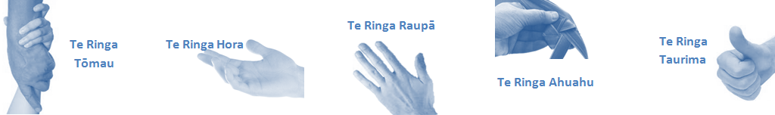

| **Capabilities** | **Capability Definition** | **Achievement Indicators** |
| --- | --- | --- |
| **Communication and Personal Interaction**  **Te Ringa Hora**  ***the open hand (denoting someone who is sociable)*** | Communicates relevant information in a timely manner to those who need to know at a level that is understood. | * Transfers information effectively verbally and writes clearly, coherently and succinctly. * Shares well thought out, concise and timely information with others using appropriate mediums. * Organisational updates are provided to staff by way of relaying in general terms but more importantly what affect it has on the unit and how staff can help where necessary to achieve any requirements. * Builds team spirit, facilitates resolution of conflict within the team, promotes/protects team reputation, shows commitment to contributing to the teams’ success. * Maintains and promotes high standards of social, ethical and organisational norms. |
| Fosters a team environment and encourages collaboration between team and departments within Lakes. | * Articulates differing perspectives on an issue and can see the merit of alternative points of view. * Works with other managers and teams to streamline processes for the best efficiency for both teams. * Provides staff who have concerns about another team process, a different point of view to consider. |
| Connects with people to build trust and confidence. | * Connects with others, listens, reads people and situations and communicates tactfully. * Gets to know their team members and treats them with respect, valuing their individuality and contributions. |
| **Strategy & Performance**  **Te Ringa Raupā**  ***the roughened hand (symbolising a hard worker)*** | Delegates appropriately within team utilising individual skills to achieve results. | * Understands individuals’ strengths and weaknesses to utilise or increase skills for those individuals. * Assigns and sub-delegates staff to teams to allow for development and succession planning. |
| Understands the unit requirements and the implications of the units achievements on the overall service delivery. | * Ensures decision making complies with organisational strategies. * Recognises decisions made within the unit affect overall results of the service and Lakes. * Works with Service Manager to maximise unit efficiency. |
| **Development and Change**  **Te Ringa Ahuahu**  ***the hand that shapes or fashions something (refers to someone who is innovative)*** | Works to include staff in change minimising barriers to implementation. | * Questions traditional ways of doing things when choosing a course of action or finds new combinations of old elements to form an innovative solution. * Continually strives for new and improved work processes that will result in greater effectiveness and efficiencies. * Openly broaches concern with staff from the outset asking for their ideas and input. * Gives examples of what might help to resolve the issue/concern. * Seeks opportunities to improve performance and seeks feedback to measure and improve. * Encourages staff participation in possible solution process. * Allows staff input to possible solutions to concern. * Gives careful consideration to staff ideas and offers alterations to suggestions where necessary. |
| Articulates decisions and reasoning behind change enable buy-in to results. | * Develops an informative response to the team including trends, data, process and benefits of the decided process/change. * Allows feedback to decision to enable ‘tinkering’ to be made where appropriate. |
| **Personal Accountability**  **Te Ringa Tōmau**  ***the hand that is trustworthy*** | Manages own and encourages others to foster work/life balance. | * Ensures regular breaks are taken and own annual leave accruals are used within the 12 months following accrual. * Ensures employees within their service are taking regular annual leave breaks for the purpose of rest/recreation throughout the year. |
| Actively manages own career aspirations and development. | * Is constantly striving to acquire and maintain knowledge, skills and/or experience. * Has own career development plan and succession planning. * Seeks out development opportunities to expand knowledge and capability. * Engages in projects and activities readily which are above and beyond scope of current role. |
| **Culture and Values**  **Te Ringa Taurima**  ***the hand that nurtures, encourages, supports*** | Makes decisions based on facts and without personal bias. | * Is proactive and effective when problem solving is required. * Engages with staff member/managers/multi-disciplinary team when concerns are raised to best understand their point of view. * Appropriately investigates the concern looking at trends, situation and practices. * Critically examines repeatable risk factors. |
| Engages with mentors and supervisors for personal skill development. | * Is constantly striving to acquire and maintain knowledge, skills and/or experience. * Demonstrates a commitment to and takes responsibility for going professional development. |
| Plans, prioritises and organises work to deliver on short and long term goals. | * Purposeful about where time is invested. * Delivers relevant results within expected timeframes. |
| Encourages and promotes Lakes values and expectations. | * Role models expected behaviours and practices. * Treats staff, patients and visitors with dignity and respect. * Uses appropriate empathy to gain organisational objectives. * Is solution focused. |

| **Compulsory Requirements** | **Description** | **Expected Outcomes** |
| --- | --- | --- |
| **Māori Health** | Māori philosophies and values of health are demonstrated in work practice. | * Meaningful relationships are established with Te Aka Matua (Rotorua and Taupo Hospitals) and Te Whatu Ora Lakes Maori Health division in the planning and delivery of services. * Practices are consistent with Te Tiriti o Waitangi /The Treaty of Waitangi when working with Māori. * Delivery of safe services for Māori are facilitated by ensuring they can access treatment options and are involved in the planning and delivery of their care. * Māori are enabled to access and participate in cultural activities provided by the Te Whatu Ora Lakes. * A commitment to improving the wellbeing of Māori by increasing cultural knowledge in the Te Whatu Ora Lakes is shown. |
| **Te Iti Kahurangi** | The Lakes Way, Our Place Our Culture | * Works within the Te Iti Kahurangi framework and supporting guide document. |
| **Record Keeping** |  | * Complies with the Te Whatu Ora Lakes Corporate Records Management policy to create and maintain full and accurate records. |
| **Quality & Risk** | Patient safety is paramount to the service we deliver at Te Whatu Ora Lakes. This is to be achieved in a clinical governance framework that is culturally responsive and identifies and manages risk and opportunities to improve. | * Employees are supported to lead by example and implement a culture of continuous quality improvement. * Risks that may prevent Te Whatu Ora Lakes from achieving their goals are identified, reported, and managed. * Māori patients are provided patient-centred care to achieve positive Māori health outcomes. * Needs of Māori are reviewed and reported in the further development of practice, process and or policy. * Evidence-based methodologies are used to support improvements, e.g. kaupapa Māori methodology. * Quality care is provided to certification standards. |
| **Health & Safety** | Each individual is responsible for ensuring the safety of themselves, their colleagues, patients and their visitors and to comply with all organisational health and safety policies, procedures and guidelines. | * Implementation and reinforcement of a proactive healthy work place culture which reflects relevant Te Whatu Ora Lakes policy and legislative requirements. * Healthy lifestyles are actively promoted and participated in, within the work area. * Employees participate in Health and Safety within areas of work. * Health and Safety activities are appropriately documented within specified timeframes. * Health and Safety policies have been read and understood and are applied in the workplace. * Health and Safety policies are appropriately documented within specified timeframes and incidents are reported immediately. * Any opportunities for improving Health and Safety are reported and acted upon in a timely manner. * All near misses/incident/accidents are reported to the appropriate line manager within 24 hours. |

**Signatures:**

|  |  |
| --- | --- |
| Line Manager:  (position description approved): |  |
| Employee:  (acceptance of position description): |  |

*(Please also initial all other pages to show acceptance of position description.)*

|  |  |  |
| --- | --- | --- |
| **Person Specification** | **Essential:** | **Desirable:** |
| **Education and Qualifications:** | * APC * NZ Drivers Licence. | * Post graduate clinical and/or teaching and/or health management qualifications. |
| **Experience:** | * Minimum of 5 years experience working within the profession * Demonstrated clinical competence within health | * Comprehensive experience working in hospital environment as a clinician within the profession * Established credibility within the profession * Previous experience in management and/or clinical leadership and/or professional leadership. |
| **Knowledge:** | * Te Tiriti O Waitangi in the provision of health care services and support to Māori. * Te Tiriti O Waitangi in practice, process, policy development and decision making. * Te Whatu Ora Lakes is a Reorua organisation knowledge and understanding of Te Reo/ Correct pronunciation. | * .. |
| **Skills:** | * Pronunciation of Te Reo Māori words and names * Proficient IT skills (MS word, Excel, Powerpoint, etc). | * Te Reo Māori * .. |
| **Personal Attributes:** | * Ability to manage professional and management needs * Commitment to professional development * Innovative, proactive, supportive, resilient | * Non-smoker preferred. * .. |

**ABOUT TE WHATU ORA LAKES**

At Te Whatu Ora Lakes we place the highest value on the health and wellbeing of everyone in our community. As such all healthcare workers are expected to play a part in the creation and promotion of an environment which lives the following vision, mission and values:

### VISION

Healthy Communities – Mauriora! In this vision Mauriora refers to the Mauri - being the life essence and the source of well-being, and ora - describing the state of wellness.

### STRATEGIC MISSION

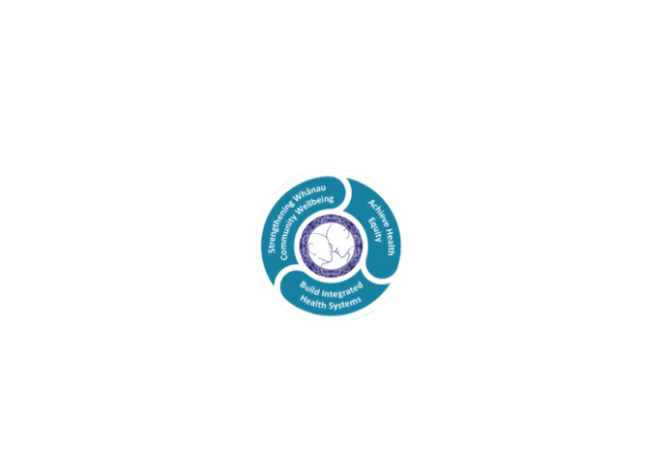

* Achieve equity in Māori health
* Build an Integrated health system
* Strengthen people, whanau & community wellbeing

### THREE CORE VALUES

Manaakitanga respect and acknowledgment of each other’s intrinsic value and contribution

Integrity truthfully and consistently acting collectively for the common good

Accountability collective and individual ownership for clinical and financial outcomes and sustainability

### TE ITI KAHURANGI – THE LAKES WAY, OUR PLACE, OUR CULTURE – WE WILL

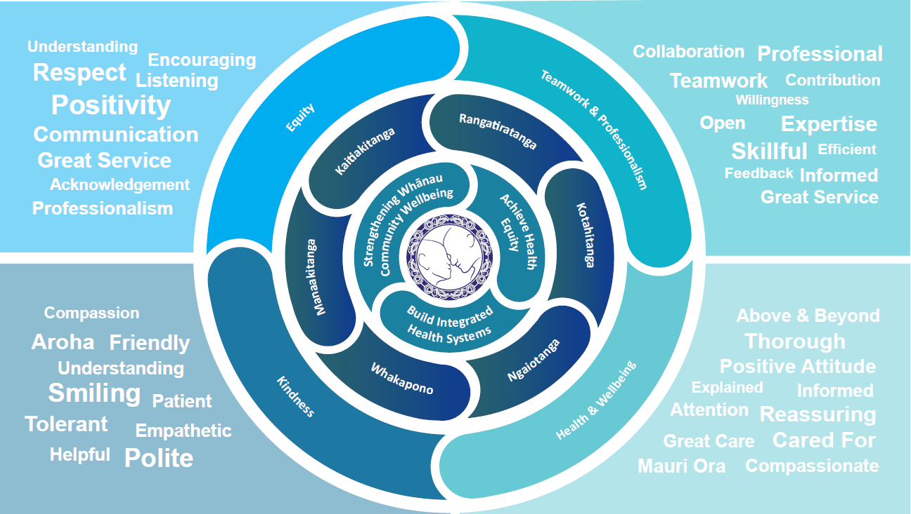

### TE TIRITI O WAITANGI

**Our expression of Te Tiriti o Waitangi**

The text of Te Tiriti, including the preamble and the three articles, along with the Ritenga Māori declaration, are the enduring foundation of our approach to achieving health and independence. Based on these foundations, we will strive to achieve the following four goals, each expressed in terms of mana.

**Mana whakahaere**

Effective and appropriate kaitiakitanga and stewardship over the health and disability system. Mana whakahaere is the exercise of control in accordance with tikanga, kaupapa and kawa Māori. This goes beyond the management of assets and resources and towards enabling Māori aspirations for health and independence.

**Mana motuhake**

Enabling the right for Māori to be Māori (Māori self-determination); to exercise their authority over their lives and to live on Māori terms and according to Māori philosophies, values and practices, including tikanga Māori.

**Mana tangata**

Achieving equity in health and disability outcomes for Māori, enhancing the mana of people across their life course and contributing to the overall health and wellbeing of Māori.

**Mana Māori**

Enabling Ritenga Māori (Māori customary rituals), which are framed by te ao Māori (the Māori world), enacted through tikanga Māori (Māori philosophy and customary practices) and encapsulated within mātauranga Māori (Māori knowledge).

Te Whatu Ora Lakes is committed within the framework of the New Zealand Public Health and Disability Act (2000) to supporting the Crown’s commitment to upholding its Tiriti promises.

### ORGANISATION STRUCTURE

