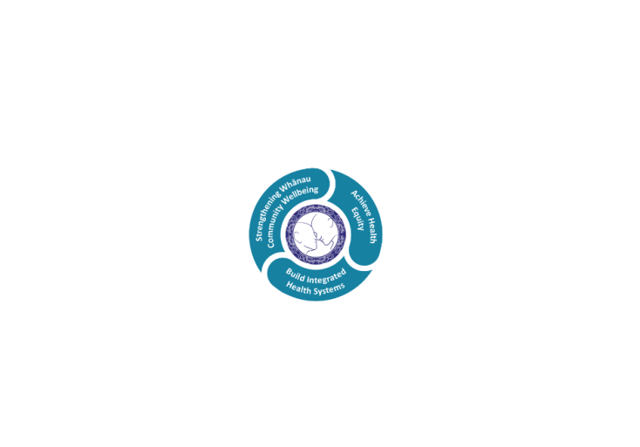



# POSITION DESCRIPTION

|  |  |  |
| --- | --- | --- |
| **Position**: | Outpatients Administrator- Front of House/Back of House/Support House (Clinical Support Service) | |
| **Responsible to:** | Team Leader- Outpatient Administration | |
| **Direct Reports:** | N/Al | |
| **Location:** | Rotorua & Taupō | |
| **Functional relationships:** | **Internal:**  Clerical Staff  Nursing Staff  Allied Health Staff  Medical Staff  Other Departments | **External**:  Nill |
| **Financial delegations:** | N/A | |
| **Date**: | .11th March 2021. | |

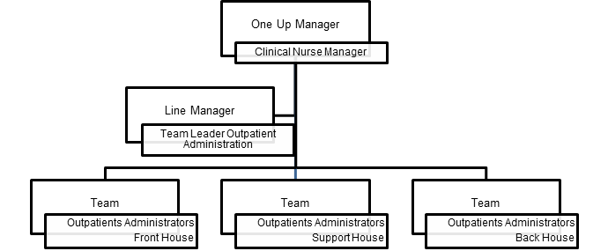

### Primary purpose(s) of the position

To provide Administrative Support within the Clinical Support Service- Specialist and Allied Health Outpatient Services

* Administration processes related to managing referrals, waiting lists and scheduling of clinic appointments and procedures
* Reception Duties
* Management of Outpatient System Data
* Clinical Records
* Delegated Duties
* General Responsibilities

|  |  |  |
| --- | --- | --- |
| **Key Objectives** | Description | Expected Outcomes |
| **Referrals**  Support House | **Referrals - To manage all referrals to the Outpatients Clinic within the Referral Management Process.** | * All referrals are date stamped upon receipt, patient demographics updated as per the referral and entered into Patient Management System. * Non NZ residents eligibility for publically funded health care is checked and updated onto the Patient Management System * Out of domicile / Service not provided referrals are re directed to the appropriate District Health Board or Service provider * All referrals are given to the triaging clinician for prioritisation and returned within the agreed Ministry of Health timeframes ( ESPI 1 ) * The priority for the patient is to be upgraded in the Patient Management System when the referrals are returned from the triaging clinician. * Patients are placed onto the waiting list following the referral triaging process. * Acknowledgment and other system letters are to be sent to the referrer and patient within the agreed Ministry of Health timeframes. * R101 report is monitored each week to ensure that referrals have been returned from triage * Referrals made from within the organisation to external providers are monitored to ensure they are received, accepted or declined. Referrer and line manager are informed of any declined status. |
| **Waitlist Management**  Back House | (**To manage wait lists within the agreed guidelines** | * The waiting lists reflect only those patients who require assessment. * Staged or suspension status on waiting lists are updated regularly. * Line Manager is informed if patient will not receive their first specialist assessment within 4months ( ESPI 2 Ministry of Health) |
| **Appointments** Back House | **Booking & Scheduling of Clinics** | * Patient appointments for assessment and procedures are coordinated based on clinical priority, diagnostics, room capacity, service booking protocols and Ministry of Heath Elective Service Performance Indicators (ESPI 2 ) * Patient Management System clinic generator is modified in accordance to service rosters ie: clinician leave, on and off ward rotation * Patient cancellations and reschedule of appointments is actioned promptly and backfilled with another patients to avoid vacant slots * Patients receive system letters designed specifically for the specialty and location they are attending ie: Rotorua Outpatients, Taupo Outpatients, Children’s Health Hub, Rangiora Clinic and Tipu Ora. * Responses from txt reminders are actioned promptly * The Did not attend (DNA ) and Was not brought ( WNB) process is followed when a further appointment is required or the patient is discharged * Clinic phones are answered promptly and courteously. * Patient enquiries are handled and processed promptly and courteously. * Changes to clinics are implemented in a timely manner to ensure timelines are met. * Outpatient phones are answered promptly and professionally to respond to patient queries related to bookings. |
| **Reception Duties**  Front House | **General Reception Duties** | * Patients are greeted in a friendly and welcoming manner at all times. * Patients attending clinics are promptly and courteously attended to when reporting to Reception. * Patients are arrived and departed in real time in the Patient Management System (IPM) * All patient demographics are updated when the patient arrives for clinics which include address, home number, cell phone number, ethnicity, GP and next of kin. * All clinic outcomes are received and inputted into (IPM) the day of clinic ie: follow up appointment, awaiting diagnostics, did not attend. * Follow up appointment’s are scheduled as per agreed booking protocols around speciality and timeframes * Direct patients to the right activity, right time, right place. * Patients are encouraged to fill out complaint or compliment form if they have feedback * System letters are sent where appropriate |
| **Outpatient System**  Front House, Back House, Support House | **Management of Outpatient System Data.** | * Monthly data reports are produced and discussed with staff and Team Leader Outpatient Administration to ensure key performance indicators are achieved. * Outpatient reports are regularly checked to ensure data integrity |
| **Clinical Records**  Front House, Back House, Support House |  | * Patient Clinical Records are tracked into the Patient Management System on arrival and departure. * Clinical files for Outpatient Clinics are retrieved in a timely manner and scanned upon receipt and/or outward bound as necessary. |
| **Delegated Duties**  Front House, Back House, Support House |  | * Other duties relevant and appropriate to the role will be delegated to the Outpatient Administrator to be completed as specified |
| **General Responsibilities**  Front House, Back House, Support House |  | * Work areas are to be kept clean, tidy and clear of clutter at all times. * Stock and consumable items are ordered appropriately within budgetary confinements. * Administration rosters are regularly checked. * Promote a team working environment that encourages and promotes information sharing and open communication. * Positive and productive working relationships are built and maintained. * To ensure service delivery is adhered to, covering other Outpatient Administrators within Outpatient Service for scheduled breaks, annual leave, sick leave and study leave will be required. * Lakes District Health Board, standard of dress policy is adhered to. * Within this role, you may be required to work in any administration role within the clinical support service ie: referral centre, bookings and front reception |

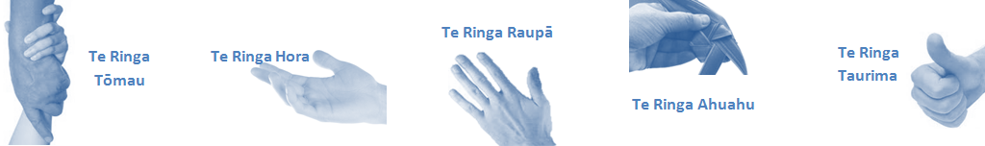

|  |  |  |
| --- | --- | --- |
| **Capabilities** | Capability definition | Achievement Indicators |
| **Communication and Personal Interaction**  **Te Ringa Hora**  ***the open hand (denoting someone who is sociable)*** | Openly communicates and cooperates with all levels of DHB employees, patients and visitors. | * Listens actively, absorbs message and responds appropriately. * Builds effective working relationships. * Establishes rapport with others and gains their respect while being adaptive in relating to different types of people and situation. * Openly and constructively participates in conversations with md team, patients, managers and visitors * Patients and visitors are appropriately welcomed and treated while within the DHB * Collegiality with team mates and md teams * Accepts differences of opinion can occur but these happen respectfully and without any continued animosity |
| **Strategy & Performance**  **Te Ringa Raupā**  ***the roughened hand (symbolising a hard worker)*** | Spends energy on delivering role requirements and meeting objectives | * Has an energetic approach to work and is self motivated. * Accepts direction and instruction of manager but is able to work effectively without direction or guidance. * Organises time and resources effectively. * Understands and work towards achievement of the organisation’s goals. * On shift is busy completing shift duties. |
| Organises own time to deliver on required tasks and duties | * Utilises effective time management strategies to meet shift duties and works towards achieving objectives in any spare moments. |
| **Development and Change**  **Te Ringa Ahuahu**  ***the hand that shapes or fashions something (refers to someone who is innovative)*** | Accepts change in day to day practices and contributes to decision making of the team. | * Can adjust behaviour to the demands of the work environment in order to remain productive through periods of transition, ambiguity, uncertainty and stress |
| Makes suggestions to increase efficiency of the unit. | * Works with managers and team to make any changes within practices work * Contributes to change processes, offering solution based ideas * Constructively makes suggestions to improve process or practices and gain efficiencies * Accepts when ideas are not accepted for implementation |
| **Personal Accountability**  **Te Ringa Tōmau**  ***the hand that is trustworthy*** | Is open with manager and colleagues and open to accepting feedback and critique to improve upon practice. | * Offers constructive criticism and accepts feedback. * Establishes rapport with others and gains their respect while being adaptive in relating to different types of people and situations, to allow improvements to be made. * Accepts all feedback and participates in feedback discussions appropriately * Responds and queries how improvements can be made * Advises manager wherever issues may be impacting on performance |
| Looks for and undertakes development activities appropriate for role and career development. | * Recognises areas that could be improved in own practice * Requests learning and development opportunities to enhance practice in role and/ or to assist where improvements can be made * Recognises and facilitates the rights of Māori clients and their whanau to participate in cultural activities. * Has a working knowledge of the Lakes DHB Māori communities. |
| **Culture and Values**  **Te Ringa Taurima**  ***the hand that nurtures, encourages, supports*** | Operates in line with DHB values and expectations and professional codes of conduct. | * Demonstrates a commitment to cultural safety by meeting and exceeding the cultural needs of clients/ customers/ colleagues. * Incorporates the Lakes Way into day to day business activities * Shows respect for patients, colleagues, * managers, md teams * Utilises the Lakes Way philosophy to engage with patients, visitors and multi-disciplinary teams |

|  |  |  |
| --- | --- | --- |
| **Compulsory Requirements** | Description | Expected Outcomes |
| **Māori Health** | Māori philosophies and values of health are demonstrated in work practice. | * Meaningful relationships are established with Te Huinga Takiora Māori in the planning and delivery of services. * Practices are consistent with Te Tiriti o Waitangi /The Treaty of Waitangi when working with Māori. * Delivery of safe services for Māori are facilitated by ensuring they can access treatment options and are involved in the planning and delivery of their care. * Māori are enabled to access and participate in cultural activities provided by the Lakes DHB. * A commitment to improving the wellbeing of Māori by increasing cultural knowledge in the Lakes DHB is shown. |
| **Te Iti Kahurangi** | The Lakes Way, Our Place Our Culture | * Works within the Te Iti Kahurangi framework and supporting guide document. |
| **Record Keeping** |  | * Complies with the Lakes DHB Corporate Records Management policy to create and maintain full and accurate records. |
| **Quality & Risk** | Patient safety is paramount to the service we deliver at Lakes District Health Board. This is to be achieved in a clinical governance framework that is culturally responsive and identifies and manages risk and opportunities to improve. | * Employees are supported to lead by example and implement a culture of continuous quality improvement. * Risks that may prevent Lakes DHB from achieving their goals are identified, reported, and managed. * Māori patients are provided patient-centred care to achieve positive Māori health outcomes. * Needs of Māori are reviewed and reported in the further development of practice, process and or policy. * Evidence-based methodologies are used to support improvements, e.g. kaupapa Māori methodology. * Quality care is provided to certification standards. |
| **Health & Safety** | Each individual is responsible for ensuring the safety of themselves, their colleagues, patients and their visitors and to comply with all organisational health and safety policies, procedures and guidelines. | * Implementation and reinforcement of a proactive healthy work place culture which reflects relevant Lakes DHB policy and legislative requirements. * Healthy lifestyles are actively promoted and participated in, within the work area. * Employees participate in Health and Safety within areas of work. * Health and Safety activities are appropriately documented within specified timeframes. * Health and Safety policies have been read and understood and are applied in the workplace. * Health and Safety policies are appropriately documented within specified timeframes and incidents are reported immediately. * Any opportunities for improving Health and Safety are reported and acted upon in a timely manner. * All near misses/incident/accidents are reported to the appropriate line manager within 24 hours. |

**Signatures:**

|  |  |
| --- | --- |
| Line Manager:  (position description approved): |  |
| Employee:  (acceptance of position description): |  |

*(Please also initial all other pages to show acceptance of position description.)*

|  |  |  |
| --- | --- | --- |
| **Person Specification** | **Essential:** | **Desirable:** |
| **Education and Qualifications:** |  | * Certificate in Computing |
| **Experience:** | * Previous experience working in hospital administration | * Previous experience working in Outpatient Service administration |
| **Knowledge:** | * Te Tiriti O Waitangi in the provision of health care services and support to Māori. * Te Tiriti O Waitangi in practice, process, policy development and decision making. |  |
| **Skills:** | * Pronunciation of Te Reo Māori words and names | * Te Reo Māori |
| **Personal Attributes:** | * Excellent interpersonal skills. * Exceptional communication skills, both written and oral. * Outstanding time management skills * Ability to relate effectively to a wide range of people. * Customer focused. * Ability to prioritise. * To be a motivated and lateral thinker, responsive to changing needs. * To be service focused. * To be capable of working unsupervised or as a team player. * Must be well presented and tidy in appearance | * Non-smoker preferred. * . |

**ABOUT LAKES DISTRICT HEALTH BOARD**

At Lakes District Health Board we place the highest value on the health and wellbeing of everyone in our community. As such all healthcare workers are expected to play a part in the creation and promotion of an environment which lives the following vision, mission and values:

### VISION

Healthy Communities – Mauriora! In this vision Mauriora refers to the Mauri - being the life essence and the source of well being, and ora - describing the state of wellness.

### STRATEGIC MISSION

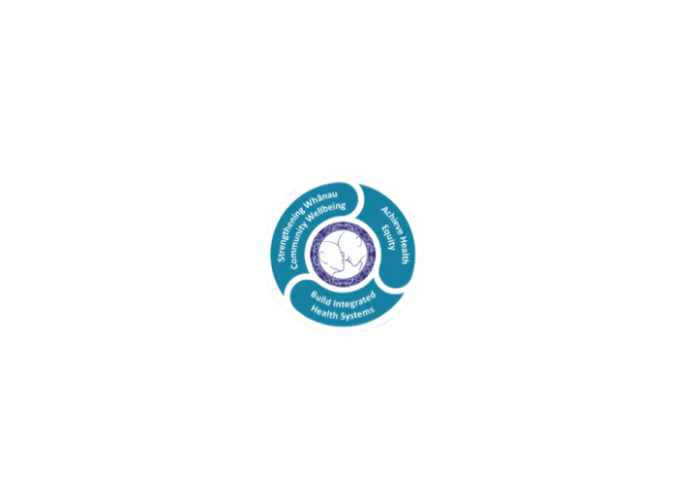

* Achieve equity in Māori health
* Build an Integrated health system
* Strengthen people, whanau & community wellbeing

### THREE CORE VALUES

Manaakitanga respect and acknowledgment of each other’s intrinsic value and contribution

Integrity truthfully and consistently acting collectively for the common good

Accountability collective and individual ownership for clinical and financial outcomes and sustainability

### TE ITI KAHURANGI – THE LAKES WAY, OUR PLACE, OUR CULTURE – WE WILL

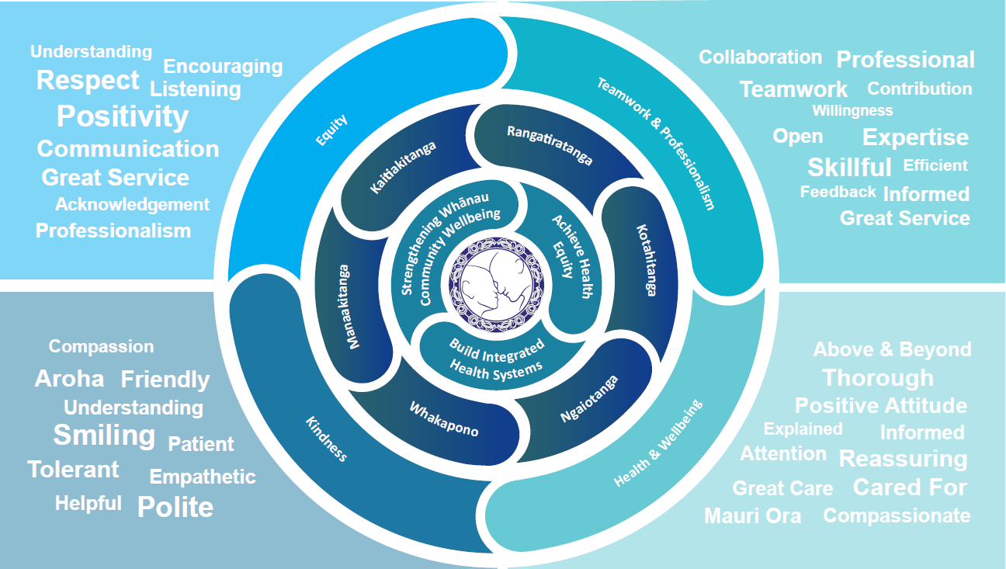

### TE TIRITI O WAITANGI

**Our expression of Te Tiriti o Waitangi**

The text of Te Tiriti, including the preamble and the three articles, along with the Ritenga Māori declaration, are the enduring foundation of our approach to achieving health and independence. Based on these foundations, we will strive to achieve the following four goals, each expressed in terms of mana.

**Mana whakahaere**

Effective and appropriate kaitiakitanga and stewardship over the health and disability system. Mana whakahaere is the exercise of control in accordance with tikanga, kaupapa and kawa Māori. This goes beyond the management of assets and resources and towards enabling Māori aspirations for health and independence.

**Mana motuhake**

Enabling the right for Māori to be Māori (Māori self-determination); to exercise their authority over their lives and to live on Māori terms and according to Māori philosophies, values and practices, including tikanga Māori.

**Mana tangata**

Achieving equity in health and disability outcomes for Māori, enhancing the mana of people across their life course and contributing to the overall health and wellbeing of Māori.

**Mana Māori**

Enabling Ritenga Māori (Māori customary rituals), which are framed by te ao Māori (the Māori world), enacted through tikanga Māori (Māori philosophy and customary practices) and encapsulated within mātauranga Māori (Māori knowledge).

Lakes DHB is committed within the framework of the New Zealand Public Health and Disability Act (2000) to supporting the Crown’s commitment to upholding its Tiriti promises.

### ORGANISATION STRUCTURE

