


About Assisted Dying

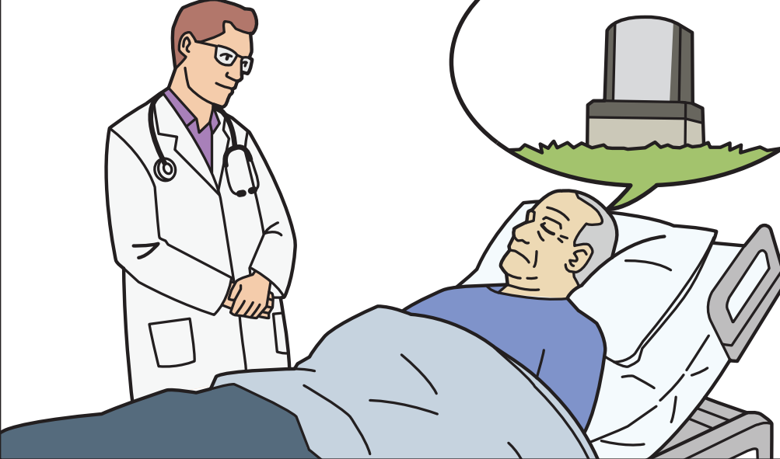

Easy Read printed Nov 2025

Before you read this


Assisted dying is a hard thing for many people to read about.

Some of the information in this document may upset people when they are reading it.


This information is not meant to scare anyone.

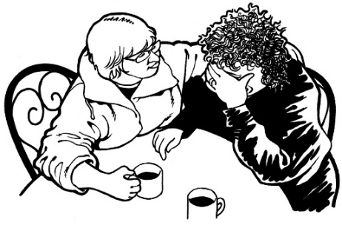
If you are worried or concerned after reading this document you can talk about it with:

- your family/friends

- your support workers.

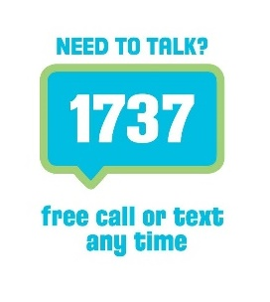
If you want to talk to someone about how you are feeling you can talk to a trained counsellor at 1737: Need to talk.


A trained counsellor is someone who can help you talk about your feelings.


You can talk to 1737: Need to talk by:

- calling: 1737

- texting: 1737.


1737: Need to talk is free to call or text.


This means it will not cost you any money to call or text 1737: Need to talk.

What you will find in here

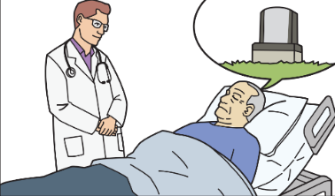
Page number:

What is assisted dying? 5

Health New Zealand 8


Ministry of Health 8

Support and Consultation for
End of Life in New Zealand
Group .9


Who can get assisted dying? 11


Who can make an
informed decision? 16
Page number:


Choosing assisted dying 17
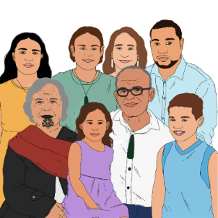

Whānau / family support 19

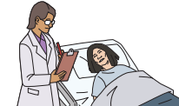
Medical practitioners 22

The assessment process 29

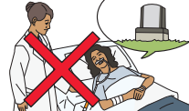
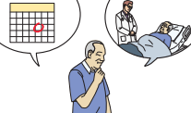
Stopping the assisted dying process 37
Planning for assisted dying 40


Where to find more
information 47

What is assisted dying?

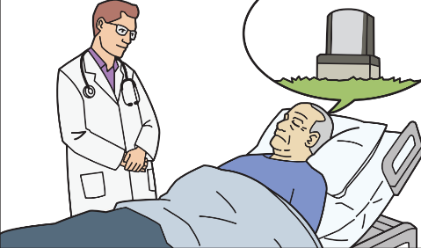
Assisted dying is a health service in New Zealand.



The service will mean that some people who are very ill can choose to take medicine to make them die.

In this document we use the word person to mean someone who may ask for assisted dying.


There are strict rules about assisted dying.


Strict rules are rules that:
- have to be followed carefully
- cannot be changed for people even a little.


There is more information about these rules on pages 11 to 15 of this document.

Assisted dying is just 1 thing some sick people can choose when they are close to the end of their lives.


Assisted dying does not replace some services like palliative care.


Palliative care is support that is given to someone who is near the end of their life.

End of their life means someone has an illness that means they will die.

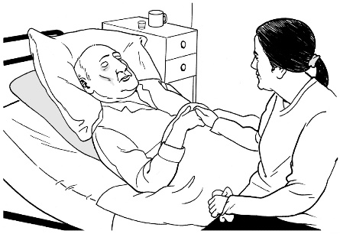
Palliative care:

- helps reduce pain

- makes people as comfortable as possible until they die.


Assisted dying is in a law called End of Life Choice Act 2019.

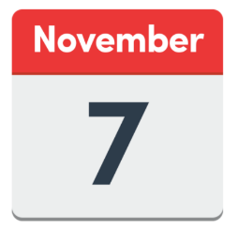

Assisted dying has been possible in New Zealand since 7 November 2021.

Health New Zealand and the Ministry of Health

Health New Zealand is a part of the government that looks after health services.


Health New Zealand:

- pays for the cost of assisted dying services
- has a team that people can talk to about assisted dying

The Ministry of Health is another part of the government that looks after health services.

- The Ministry of Health will: check that all the rules have been followed when someone asks for assisted dying

- The Ministry of Health will see how the assisted dying service is going.

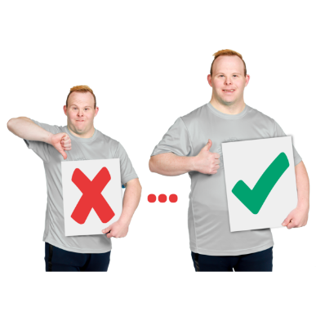
- The Ministry of Health will also work to make the service better over time.

Support and Consultation for

End of Life in New Zealand Group

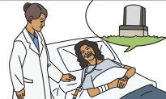
SCENZ is short for Support and Consultation for End of Life in New Zealand.


The SCENZ Group has been set up to work on assisted dying in New Zealand. They are a group that is appointed by and works with the Ministry of Health.


The SCENZ Group keeps a list of doctors who work on assisted dying services.

A person can ask for information about a doctor on this list if:

- their own doctor does not work on assisted dying services
- they do not want to talk to their own doctor.

Who can get assisted dying?


There are strict rules about who can get assisted dying.

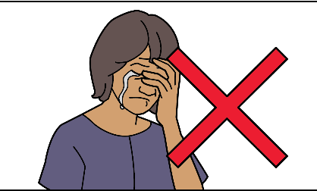
A person cannot get assisted dying just because they:
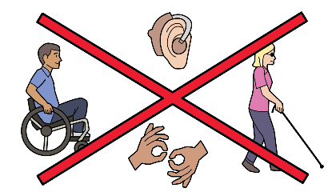
- have a mental illness
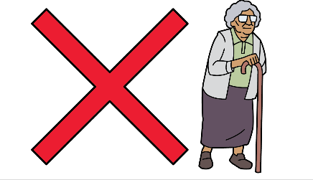
- have any kind of disability
- are an older person.
A person must have a terminal illness to get assisted dying.

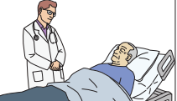
A terminal illness is an illness that:
- cannot be cured
- you will die of.

The rules say that to get assisted dying a person must be all these 6 things.

- The person must be 18 years old or older.


- The person must be a New Zealand:

  - citizen
or
  - permanent resident.

A New Zealand citizen is someone who can get a New Zealand passport.

Many New Zealand citizens are born in New Zealand.

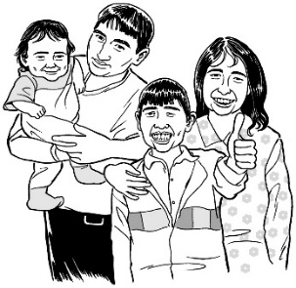
Some people who come to live in New Zealand from overseas also become New Zealand citizens.



A permanent resident is someone the government has:
- said can live in New Zealand for as long as they want
- given a document called a permanent resident visa.

The rules say that to get assisted dying a person must be all these 6 things.
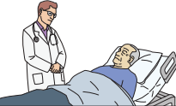

- The person must have a terminal illness that means they are likely to die within 6 months.

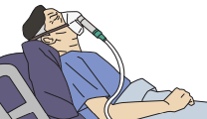
- The person must be able to do a lot less with their body than they used to do.

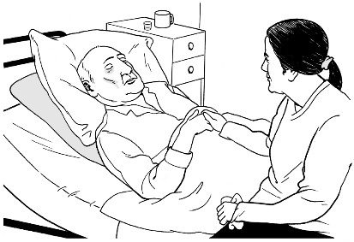

- The person must feel so bad that they cannot cope.
For example they may have very bad pain.
There must not be a way that things can be made better for them.
The rules say that to get assisted dying a person must be all these 6 things.

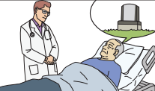
- The person must be able to make an informed decision about assisted dying.


An informed decision is when a person knows:

  - what they are deciding
  - what the decision means.

Who can make an informed decision?


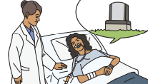
The assisted dying law says the person can make an informed decision if they can do all of these things:
- understand information about assisted dying

- remember information about assisted dying so they can make a decision
- use the information they have about assisted dying when making their decision

- tell someone about their decision.

Choosing assisted dying

Only the person can choose to get assisted dying.


They must not be making the choice because of pressure from someone else.

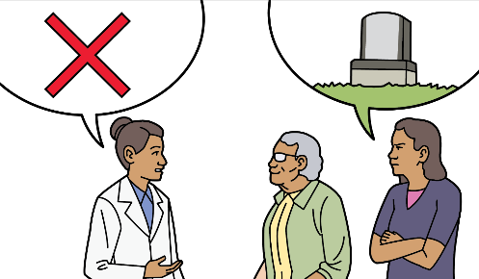
Other people cannot choose assisted dying for the person.
This includes people that the law says can make decisions for them.

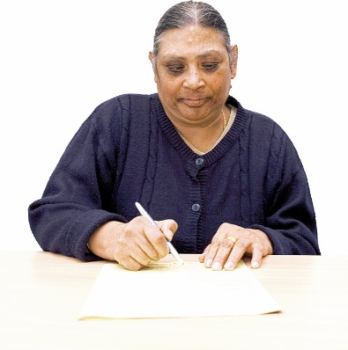
Advanced directives cannot be used for assisted dying.

An advanced directive is when you say what medical treatment you want in the future when you may not be able to decide.

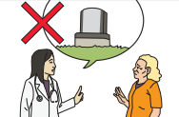
The doctor cannot talk about assisted dying with the person first.

They have to wait for the person to ask about assisted dying.

Whānau / family support

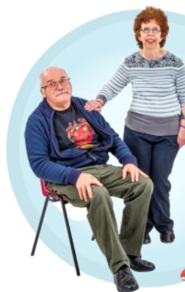
Whānau / family may mean different things for different people.

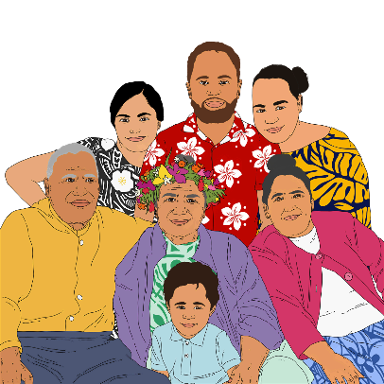
The way we use whānau / family can mean:
- close family

- wider family
- friends
- other people the person is close to.

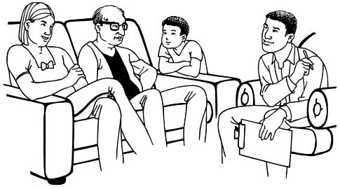
Whānau / family can be important in supporting the person.

The person may find it helpful to talk to whānau / family or other support people.


The person can ask questions about assisted dying with their whānau / family.
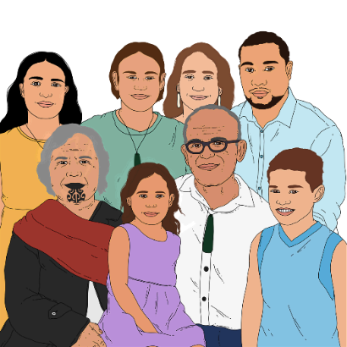
The person can talk with whānau / family about what is important to them.

They must be given time to talk with their whānau / family.

The person does not have to talk to their whānau / family if they do not want to.
Some of the ways whānau / family can support the person are:
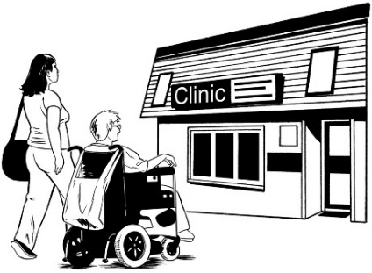
- helping them think about what they want to happen at the end of their life

- going with them to medical appointments
- supporting the person with personal care like food or showering
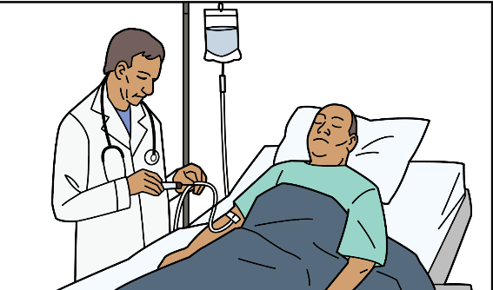
- giving support when the person takes the medicine to make them die
- being comforting.
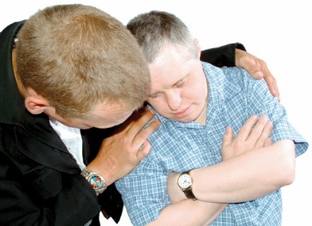
Being comforting means making someone feel better by being there for them.

Medical practitioners

A few different medical practitioners are involved with a person who is making a decision about assisted dying.

- Attending medical practitioner

A doctor will support the person through the assisted dying process.

This doctor is called the attending medical practitioner.

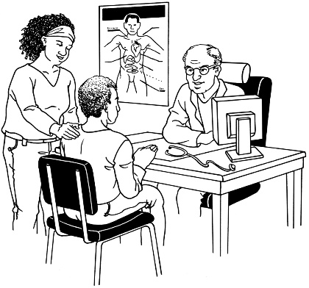
Sometimes the attending medical practitioner will be the doctor the person usually sees like their GP / General Practitioner.

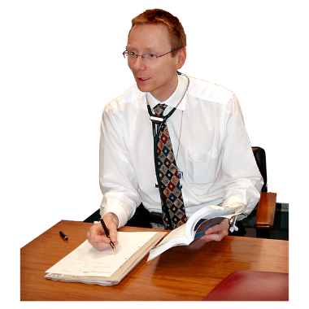
Not all doctors work on assisted dying services.


This may be because:
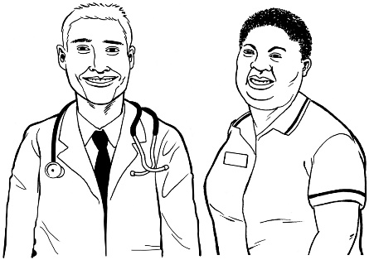
- they do not think it is right
- they have not trained enough on the right things to do it well.

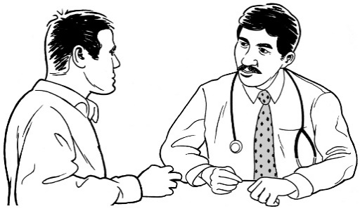
If a doctor does not work on assisted dying service they should:
- tell the person why
- support the person to find another doctor.

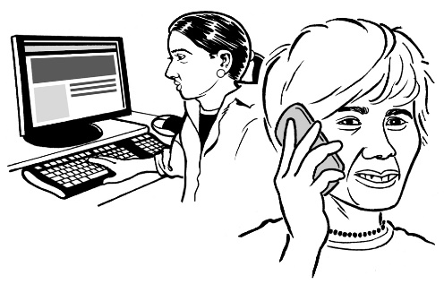
Finding another doctor could mean:
- telling the person about the SCENZ Group

- contacting the SCENZ Group for the person

- telling the person about another doctor they can see.


The person can contact the SCENZ Group for support to find a doctor who does assisted dying services.

- Independent medical practitioner

If the attending medical practitioner thinks the person fits the rules for assisted dying they will ask another doctor to check as well.

The second doctor is called the independent medical practitioner.


This is to be sure:

- they get things right

- that the person meets all the rules for assisted dying.

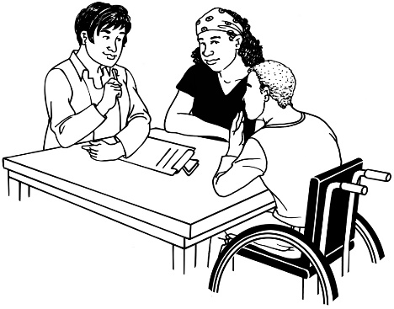
- Psychiatrist

The person may also need to see a psychiatrist.

A psychiatrist is a doctor who knows a lot about mental health.

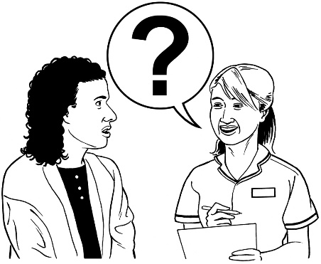
- Nurse practitioner

The person may also have a nurse practitioner.

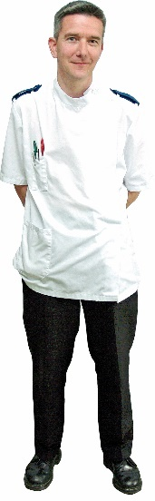
A nurse practitioner is a nurse who:
- has done more study
- can do some of the things a doctor usually does.

This nurse practitioner is called the attending nurse practitioner.
An attending nurse practitioner works with the attending medical practitioner.

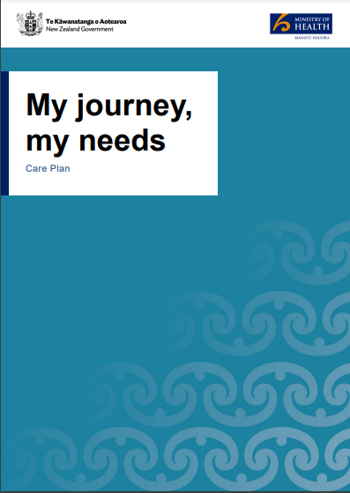
The attending practitioner can support with planning.

In this document we use attending practitioner to mean either:

- the attending medical practitioner

or

- the attending nurse practitioner.
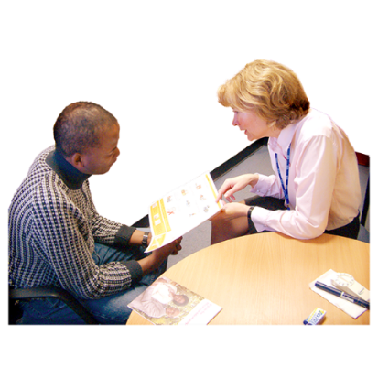

Other health workers the person usually sees may also support them.


A person does not have to pay money for assisted dying.

They may still have to pay for other health costs.

The person should keep speaking to their usual doctor for other medical care.

The assessment process

The assessment process is the way of checking if a person can get assisted dying.


The law says how the assessment process needs to go.

The assessment process is important to keep the person safe.

The assessment process makes sure the person:
- meets the rules
- wants assisted dying.


Each part of the process:
- must happen in the right order

- needs forms to be filled out
- will include one or more appointments.


The attending practitioner may visit the person for the appointment if needed.


Some appointments may be able to happen by:

- phone call
- video call.

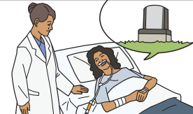
The assessment process starts with the application.

The application is when the person asks the attending medical practitioner for assisted dying.
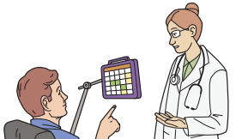

The person should be clear it is assisted dying they are asking for.

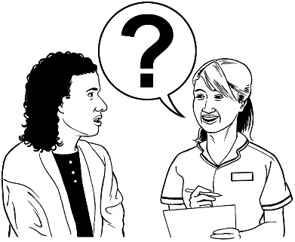
The attending medical practitioner may ask some questions to check they understand what the person is asking for.

When the person asks for assisted dying the attending medical practitioner will:

- talk to the person about other choices they can make for their care
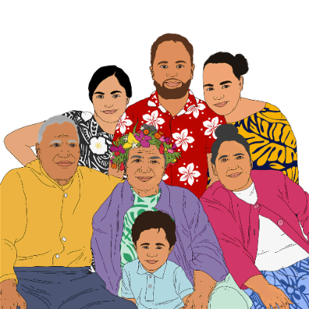
- tell the person they can change their mind at any time before they take the medicine
- encourage the person to talk about their choice with their whānau / family.


To make sure the person is not being pressured the attending medical practitioner will talk to:
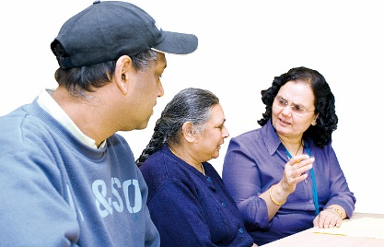
- other health workers who care for the person
- the whānau / family of the person if the person says this is ok.


If the person wants to go ahead with assisted dying they will sign a form.


If they cannot sign someone else can sign for them but the person must be there when they do.

The attending medical practitioner will check the person meets the rules for assisted dying.

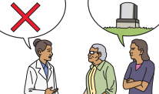
They will also check the person is making the choice without pressure from someone else.

If the attending medical practitioner thinks the person meets the rules the person will see an independent medical practitioner.

The independent medical practitioner will also check if the person meets the rules for assisted dying.

If the doctors are not sure if the person can make their own decision then the person must see a psychiatrist.
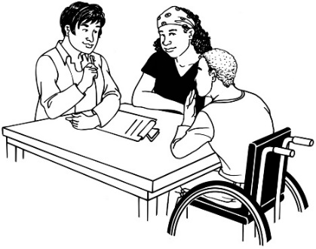

The psychiatrist will decide if the person can make an informed decision about assisted dying.

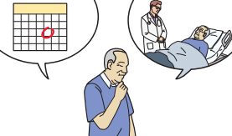
The attending medical practitioner will tell the person if they can get assisted dying.

If they can get assisted dying they will start making plans.

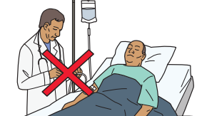
If they cannot get assisted dying then the attending medical practitioner will:

explain the reason why

make sure the person has other medical treatment.

Stopping the assisted dying process

The assisted dying process can stop at any time until the person takes the medicine.

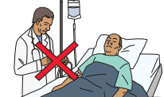
The process will stop if the person does not fit the rules for assisted dying.

The process will also stop if things change so the person no longer fits the rules.

For example a person may stop being able to make an informed decision.

The process will also stop if an attending practitioner thinks the person is being pressured.

If the process stops at any point the attending practitioner will:
- explain why
- talk to the person about other options for their care.

The process must also stop if the person changes their mind.

The attending medical practitioner must make sure the person understands they can change their mind.

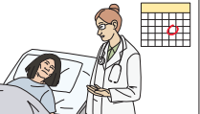
Before the person gets the medicine to make them die the attending practitioner will ask them if they still want to take it.

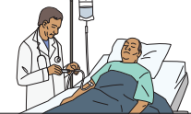
The person has 3 choices.

The person can choose:

- to take the medicine now
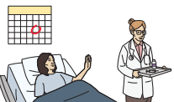
- to change the date they take the medicine
- to stop the process and not get assisted dying.

If they choose to change the date it must not be more than 6 months away from the first date they chose.

Planning for assisted dying


If the person fits the rules to get assisted dying there are still choices they need to make.

The attending practitioner will support the person making these choices.

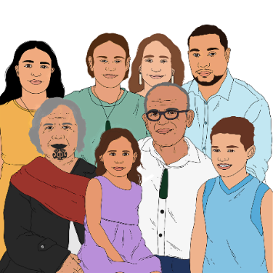
The attending practitioner should encourage the person to talk with their whānau / family about their plans.


There will probably be more than 1 meeting about planning.

The person or their whānau / family can ask questions.
The attending medical practitioner will talk to the person about the date and time assisted dying will happen.


The person will:
- choose the date and time
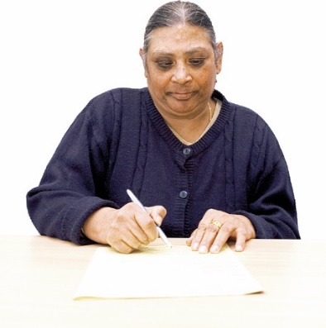
- fill in a form with this information.

The person can choose how they take the medicine that will make them die.


There are 4 ways of taking the medicine that will make the person die.

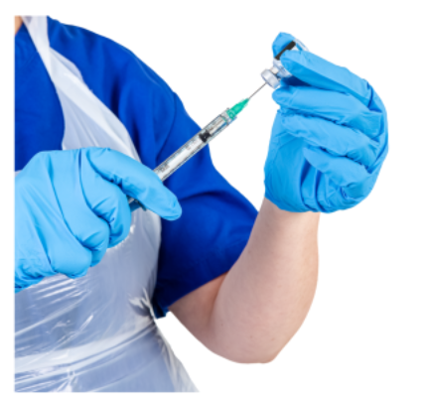
The person can choose to:
- have the attending practitioner inject the medicine with a needle
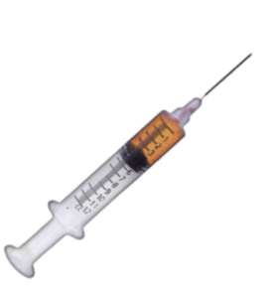
- have the attending practitioner put the medicine in the mouth of the person or in their feeding tube
- start the injection themselves
- take it through their mouth themselves.

If the person chooses to take the medication themselves the attending practitioner must still be there.


The attending practitioner will:
- talk about these choices
- make sure the person understands the choices
- tell the person if some of the choices will not work well for the person
- explain what will happen on the day the assisted dying happens.


Most people who have assisted dying will want to die at home if they can.


The attending medical practitioner will travel to the place the person lives.

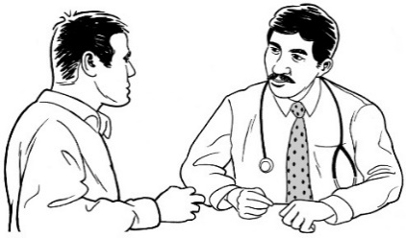
If assisted dying cannot take place at home the person and their whānau/family can talk with the attending medical practitioner about other options.


The person can choose who they want to be there when they die.

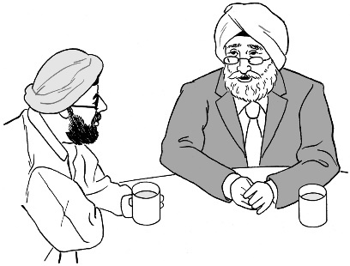
This might include:
- whānau / family

- friends
- a leader from their culture or religion.

The attending practitioner may also ask the person if another doctor or nurse can be there to help with the assisted dying.


The person can choose to have things done that are important to them like:

- having someone read a karakia or prayer
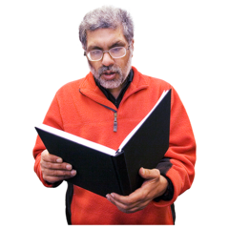
- playing music
- having someone read something important to the person.

The attending practitioner will talk to the person about these plans.

This is to make sure:
- everyone knows what will happen
- the things the person has chosen to happen.

Where to find more information


More information about the assisted dying service is on the Health New Zealand website at:
https://info.health.nz/conditions-treatments/end-of-life-care/assisted-dying

You can also contact us by email:
AssistedDying@tewhatuora.govt.nz


You can call us on:
0800 223 852
This information has been written by Health New Zealand.
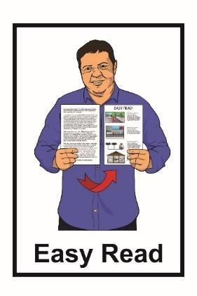
It has been translated into Easy Read by the Make It Easy Service of People First New Zealand Inc. Ngā Tāngata Tuatahi.


The ideas in this document are not the ideas of People First New Zealand Inc. Ngā Tāngata Tuatahi.

Make It Easy uses images from:

- Changepeople.org

- Photosymbols.com

- Sam Corliss
- Huriana Kopeke-Te Aho.


All images used in this Easy Read document are subject to copyright rules and cannot be used without permission.

